Core Java:

JDK contains 🡪 JRE + compiler/debugger/Javadocor

JDK is to develop and run java code.

JDK is a platform-specific software and that’s why we have separate installers for Windows, Mac, and Unix systems. For example, if you navigate to the Java download page at [**https://www.oracle.com/in/java/technologies/javase-downloads.html**](https://www.oracle.com/in/java/technologies/javase-downloads.html), you will see different installers for different operating systems (Windows, Linux, Mac etc):

JRE is the combination of JVM + Class libraries which is responsible to run Java programs in the run time. So we can say JRE is the implementation of JVM.

If you want to execute programs means if you have .class file(byte code) then JRE would be sufficient to execute your .class file.

JVM translates the byte code into machine language, and since the machine language depends on the operating system being used, the **JVM is platform (operating system) dependent.**

rt.jar stands for runtime and contains all of the compiled class files for the core Java Runtime environment.

One of the most important things to know about rt.jar is that all the classes in this JAR file is known to JVM, which means JVM doesn't do all the checks it does while loading any other JAR from any other location.  This is done due to various performance reasons and that's why these classes are loaded by [bootstrap or primordial class loaders](http://javarevisited.blogspot.sg/2012/12/how-classloader-works-in-java.html). Don't try to include your class files in rt.jar, as its not advised by Java. It also compromises with any security.  
  
Read more: <https://javarevisited.blogspot.com/2015/01/what-is-rtjar-in-javajdkjre-why-its-important.html#ixzz8PhqKalPM>

You must include rt.jar in your classpath, otherwise you don't have access to core classes e.g. java.lang.String, java.lang.Thread, java.util.ArrayList or java.io.InputStream and all other classes from Java API

Since all the classes in the rt.jar are known to the JVM, these classes tend to be left alone with various checks that JVM does while loading these classes onto it. This is also done for various performance reasons. These jars are loaded by primodial class loaders and that’s the reason these classes avoid the basic security checks which the JVM does for other jars/classes.  
  
Read more: <https://javarevisited.blogspot.com/2015/01/what-is-rtjar-in-javajdkjre-why-its-important.html#ixzz806Tp0Oap>

The flow is :

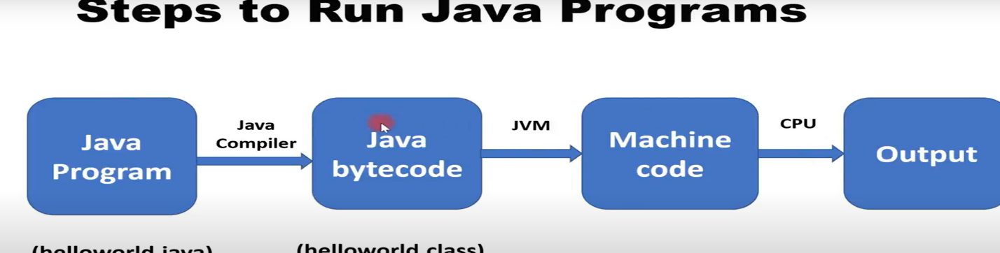

JVM Architecture:

https://dzone.com/articles/jvm-architecture-explained

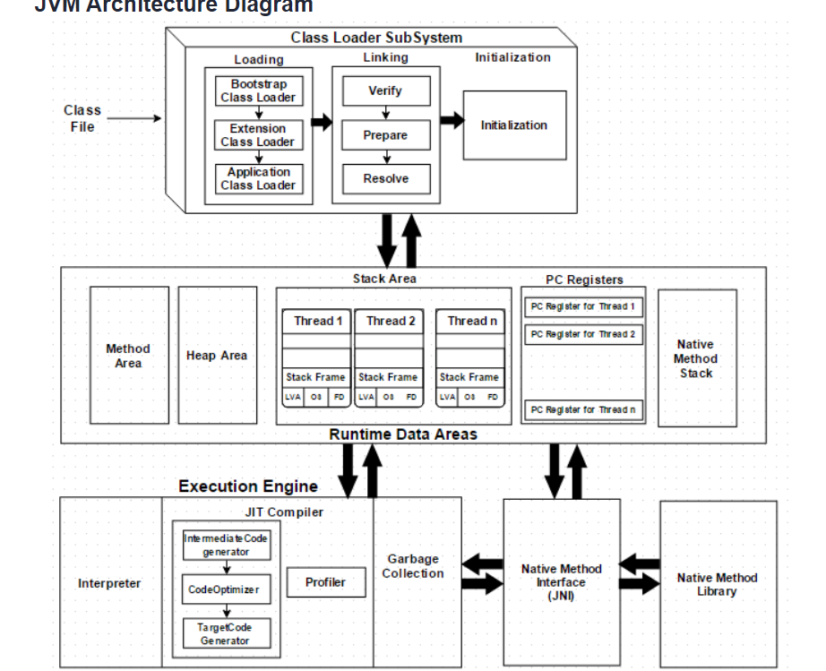

**Java Memory Model:**

Mainly consist of two memories:

Spring constant pool is part of Heap memory now.

**Stack**: Consist of reference to heap objects and also local variables stack

**Heap Memory:** Mainly Young generation and Old Generation.

Young generation consist of Eden space where first objects get stored and it has little memory.

Once GC runs, objects gets moved to Survivor S1 space and with next time GC, these gets moved to Survivor S2 space. This entire process comes under Young generation

After multiple GC runs, if any object survives then those will be moved to Old generation.

**Interview**: ZGC: Designed for applications requiring ultra-low pause times, ZGC performs concurrent garbage collection without significant interruption to the application.

1. G1 (Garbage-First) GC: A server-style GC that divides the heap into regions and performs garbage collection on smaller subsets of the heap to minimize pauses and improve throughput.

[**https://www.youtube.com/watch?v=ckYwv4\_Qtmo**](https://www.youtube.com/watch?v=ckYwv4_Qtmo)

**https://dzone.com/articles/java-memory-management**

**The Stack:**

* 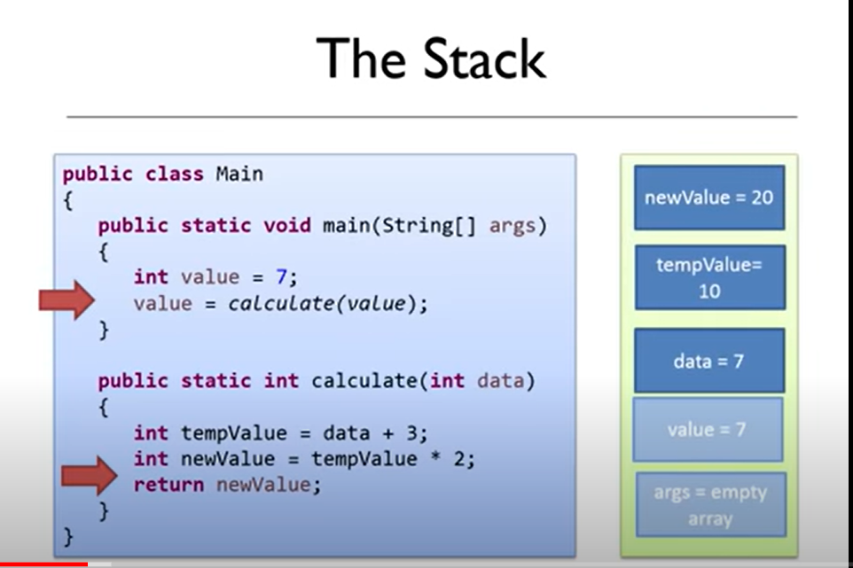

Here Stack is First in Last Out. In Stack all local variables, parameters and object references will get stored.

If we see above picture args = empty array first pushed to Stack and then value = 7 and next calculate method gets called so first one is parameter which is data = 7 gets pushed and then tempValue, newValue are stored in Stack. Once return statement comes then all the local variables in that method gets popped from stack and below 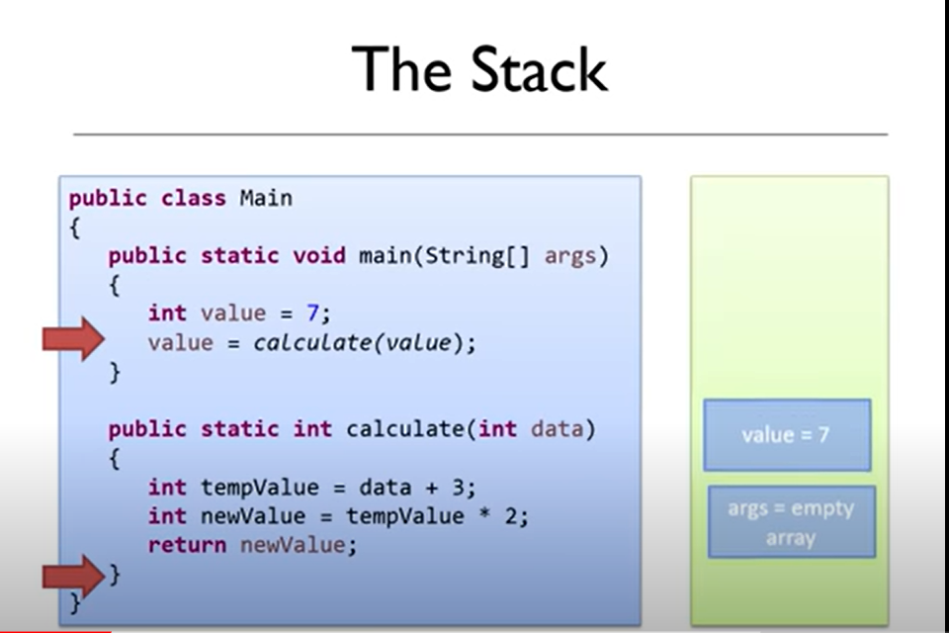

When method comes to close parentheses then calculate method variables are removed from stack and stack state will come to the state where it was before calling calculate.

Now when control comes to value = calculate(value) then value will be updated to latest value and when final parentheses is reached in the class all the data in the stack will be cleared.

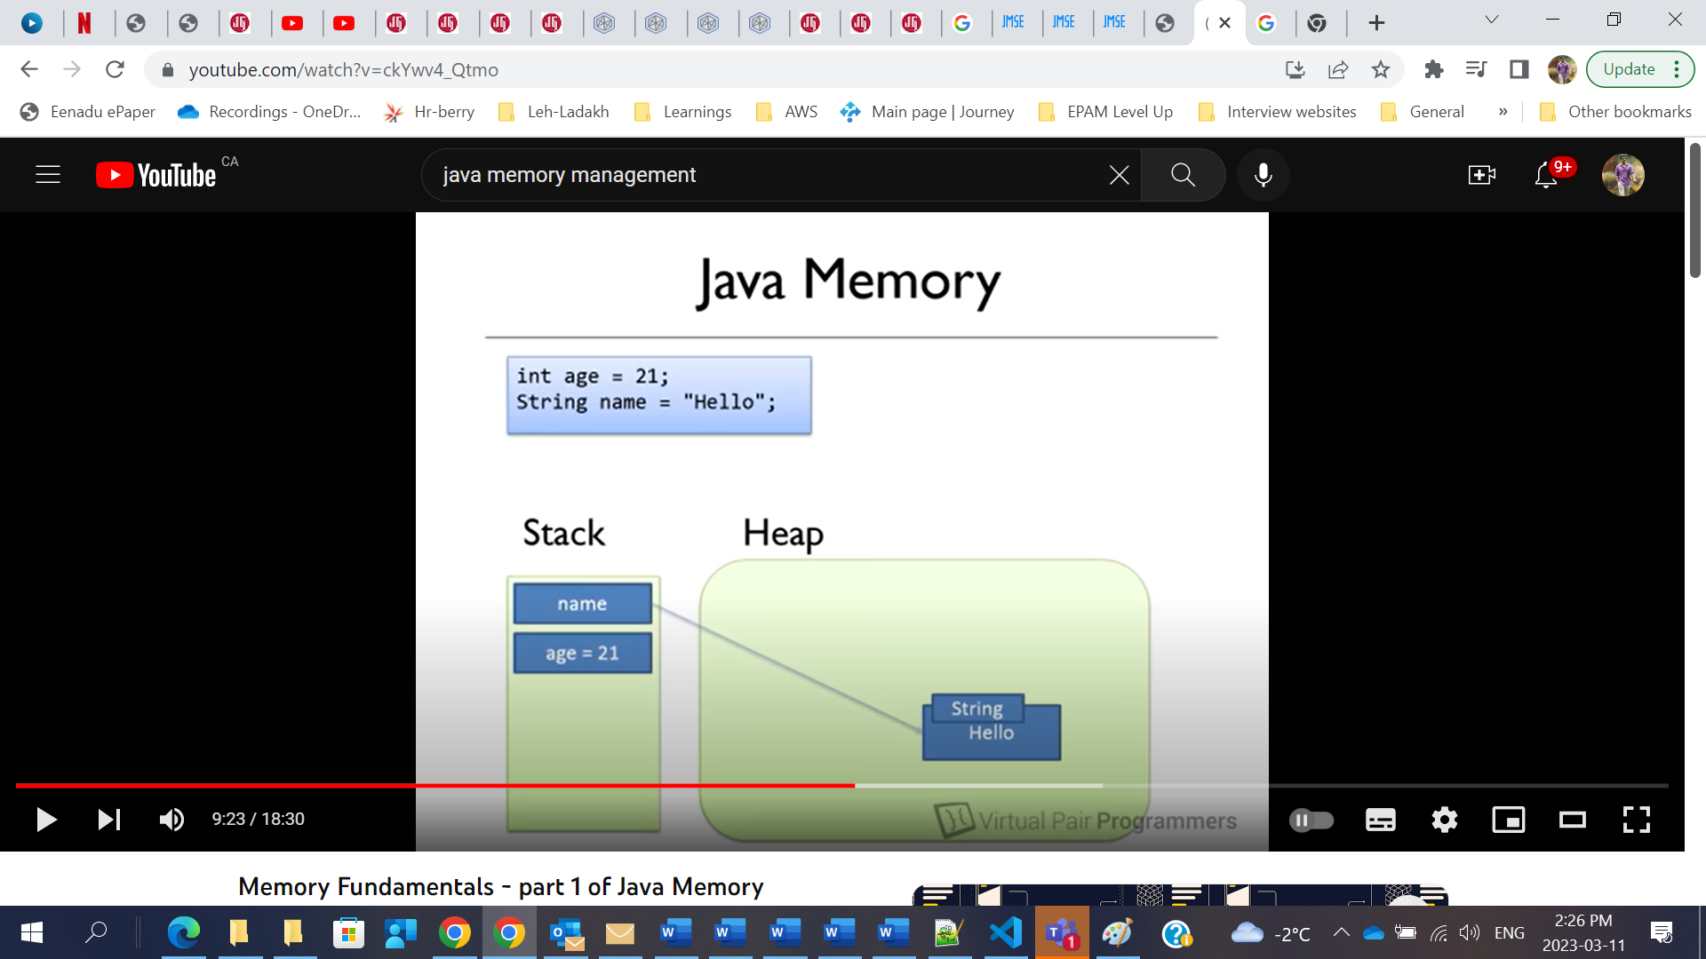

**Here int age = 21 is** local variable so it will be stored in stack.

But as we know objects and Strings are stored in Heap memory, now here String “Hello” object is physically created in Heap memory but reference name is created in Stack.

**Garbage Collection:**

[**https://dzone.com/articles/java-memory-management**](https://dzone.com/articles/java-memory-management)

### ****Garbage Collector Types****

Actually, the JVM has three types of garbage collectors, and the programmer can choose which one should be used. By default, Java chooses the garbage collector type to be used based on the underlying hardware.

**1. Serial GC** – A single thread collector. Mostly applies to small applications with small data usage. Can be enabled by specifying the command line option: -XX:+UseSerialGC

**2. Parallel GC** – Even from the naming, the difference between Serial and Parallel would be that Parallel GC uses multiple threads to perform the garbage collecting process. This GC type is also known as the throughput collector. It can be enabled by explicitly specifying the option: -XX:+UseParallelGC

**3. Mostly concurrent GC** – If you remember, earlier in this article, it was mentioned that the garbage collecting process is actually pretty expensive, and when it runs, all thread are paused. However, we have this mostly concurrent GC type, which states that it works concurrent to the application. However, there is a reason why it is “mostly” concurrent. It does not work 100% concurrently to the application. There is a period of time for which the threads are paused. Still, the pause is kept as short as possible to achieve the best GC performance. Actually, there are 2 types of mostly concurrent GCs:

**3.1 Garbage First** – high throughput with a reasonable application pause time. Enabled with the option: -XX:+UseG1GC

**3.2 Concurrent Mark Sweep** – The application pause time is kept to a minimum. It can be used by specifying the option: -XX:+UseConcMarkSweepGC. As of JDK 9, this GC type is deprecated.

* Use the -verbose:gc option to get the garbage collection output. Each time a garbage collection takes place, an output will be generated.
* If a Java application crashes with an OutOfMemoryError and you need some extra info to detect the leak, run the process with the –XX:HeapDumpOnOutOfMemory parameter, which will create a heap dump file when this error happens next time.
* JVisualVM also has the functionality to make a heap dump at a certain point, so you could analyze, per class, how much memory it occupies.

**How to increase performance of Java application:**

Most important/key HotSpot **JVM** **components related to performance** are >

* **Heap,**
* **JIT (Just In Time) Compiler** and
* **Garbage collector**

[**https://www.baeldung.com/java-reference-types**](https://www.baeldung.com/java-reference-types)

1. Check reference types like how hard reference to object is created.

We have Strong, weak, Soft and Phantom

1. Use local variables as much as possible so when method is returned then reference to object is also closed
2. Check how hard you are referring to object.
3. **Strong**: Default one when we create object using new operator. It is eligible only when we assign obj = null;
4. **Weak**:

// Strong Reference

        Gfg g = **new** Gfg();

       g.x();

       // Creating Weak Reference to Gfg-type object to which 'g'

        // is also pointing.

        WeakReference<Gfg> weakref = **new** WeakReference<Gfg>(g);

        //Now, Gfg-type object to which 'g' was pointing earlier

        //is available for garbage collection.

        //But, it will be garbage collected only when JVM needs memory.

        g = **null**;

        // You can retrieve back the object which

        // has been weakly referenced.

        // It successfully calls the method.

        g = weakref.get();

 g.x();

* These references are used in real time applications while establishing a DBConnection which might be cleaned up by Garbage Collector when the application using the database gets closed.
* a weak reference to an object from the heap is most likely to not survive after the next garbage collection process. A weak reference is created as follows:
* 1
* WeakReference<StringBuilder> reference = new WeakReference<>(new StringBuilder());

1. These types of references are used for more memory-sensitive scenarios, since those are going to be garbage collected only when your application is running low on memory. Therefore, as long as there is no critical need to free up some space, the garbage collector will not touch softly reachable objects. Java guarantees that all soft referenced objects are cleaned up before it throws an OutOfMemoryError

we can force the JVM to add it to the string pool by adding the .intern() method at the end of computed string:

1. Phantom references are replacement for finalizers as if we use finalizers there is no guarantee that it will get garbage collected but with Phantom references it will get added to the queue.

## **Tips and Tricks**

* To minimize the memory footprint, limit the scope of the variables as much as possible. Remember that each time the top scope from the stack is popped up, the references from that scope are lost, and this could make objects eligible for garbage collecting.
* Explicitly refer to null obsolete references. That will make objects those refer to eligible for garbage collecting.
* Avoid finalizers. They slow down the process and they do not guarantee anything. Prefer phantom references for cleanup work.
* Do not use strong references where weak or soft references apply. The most common memory pitfalls are caching scenarios,when data is held in memory even if it might not be needed.
* JVisualVM also has the functionality to make a heap dump at a certain point, so you could analyze, per class, how much memory it occupies.
* Configure your JVM based on your application requirements. Explicitly specify the heap size for the JVM when running the application. The memory allocation process is also expensive, so allocate a reasonable initial and maximum amount of memory for the heap. If you know it will not make sense to start with a small initial heap size from the beginning, the JVM will extend this memory space. Specifying the memory options with the following options:
  + Initial heap size -Xms512m – set the initial heap size to 512 megabytes.
  + Maximum heap size -Xmx1024m – set the maximum heap size to 1024 megabytes.
  + Thread stack size -Xss1m – set the thread stack size to 1 megabytes.
  + Young generation size -Xmn256m – set the young generation size to 256 megabytes.
* If a Java application crashes with an OutOfMemoryError and you need some extra info to detect the leak, run the process with the –XX:HeapDumpOnOutOfMemory parameter, which will create a heap dump file when this error happens next time.
* Use the -verbose:gc option to get the garbage collection output. Each time a garbage collection takes place, an output will be generated.

**JVisual VM and Heap Dumps:**

**https://www.youtube.com/watch?v=JoQN4xoXY5Y**

Extract data from JVM. It is used to track heap and memory leaks. We can analyze garbage collector and CPU profiling.

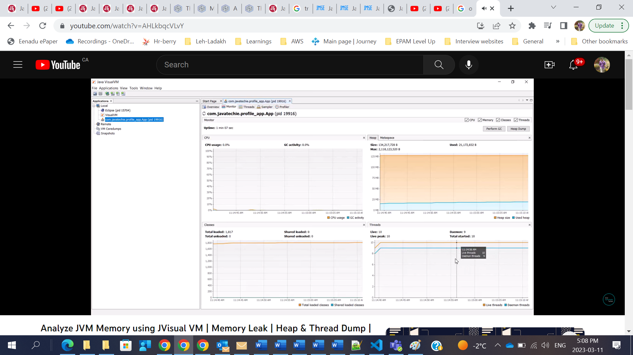

1. Memory for Class metadata is allocated only from native memory. Earlier, it was from the Contiguous Java Heap Memory. [MetaSpace Allocation].

String constant pool is now part of Heap Memory.

1. PermGen and MetaSpace are not a direct movement. (Some items from PermGen have been moved to MetaSpace. There are some miscellaneous items moved to the Heap Space, like Interned Strings) [PermGen <> MetaSpace, Heap Space Impact].
2. PermGen had a fixed size, but MetaSpace can Auto-Tune and Auto-Increase depending on the underlying OS. [MetaSpace Size Efficiency].
3. Classes can be de-allocated concurrently without GC pauses. It is more efficient than in PermGen, as that required frequent GC pauses. [MetaSpace Performance].
4. **Foreign-Memory Access API:** Java 14 introduced a Foreign-Memory Access API, which allows Java code to safely and efficiently access foreign memory outside of the Java heap. This feature is particularly useful for memory-intensive applications and for interfacing with other systems and languages. [Details](https://openjdk.org/jeps/370)
5. **Records also new Memory Management feature**

the only difference in the generated bytecode between a record and the equivalent class is in the implementation of methods: toString, equals and hashCode. Which in the case of a record class are implemented using an invoke dynamic (indy) instruction to the same bootstrap method at class: java.lang.runtime.ObjectMethods (freshly added in the records project). The fact that these three methods, toString, equals and hashCode, invoke the same bootstrap method saves more space in the class file than invoking 3 different bootstraps methods. And of course as already shown in the other answers, saves more space than generating the obvious bytecode

1. **G1GC garbage collector**

**Runtime Polymorphism:**

Why we use

Parent p = new Child();

Because if we use like this then child object means here reference “p” will have access to parent class methods as well.

**Interfaces**:

When we have two interfaces, and both have same method name method1() then one class implements both interfaces then it will give compile time error so to fix this implemented class must provide implementation for that method or

In Class

Method1() {

return interface1.super.method1();

or

return interface2.super.method1();

}

**Abstract Classes:**

interface A {

void a();

void b();

void c();

void d();

}

// The abstract class can also be used to provide some implementation of the interface.

//In such case, the end user may not be forced to override all the methods of the interface.

abstract class B implements A {

public void c() {

System.out.println("I am c");

}

}

class M extends B {

public void a() {

System.out.println("I am a");

}

public void b() {

System.out.println("I am b");

}

public void d() {

System.out.println("I am d");

}

}

class Test5 {

public static void main(String args[]) {

final A a = new M();

a.a();

a.b();

a.c();

a.d();

}

}

When interface has method

Interface A {

Default void show(){

SOP(“This is interface”);

}

}

Class B {

Default void show(){

SOP(“This is Class B”);

}

}

Class C extends B implements A then

* This is ClassB gets printed as public in class will have more power and override show method in interface.

**Record**:

* Record is replacement to Data Carrier Classes like we create for @RequestBody in REST API.
* public record CompletionRequest(String prompt) {  
  }

So this will have private and final fields with getters and also toString, equals and hashcode overrided. But we will not have default constructor in record class.

* If you want extra check with your record then you can create constructor in record class and add condition

public record CompletionRequest(String prompt) {

public record CompletionRequest(String prompt) {

If(prompt.equals(“”){

}  
}  
}

* Record class cannot extend any other class because it already extends Record class but it can implement interfaces
* You can declare static variables but not instance variables.

**SEALED CLASS:**

**Abstract Class vs Interfaces:**

Abstract classes have no restrictions on field and method modifiers, while in an interface, all are public by default. We can have instance and static initialization blocks in an abstract class, whereas we can never have them in the interface. Abstract classes may also have constructors which will get executed during the child object's instantiation.

I would use abstract class when trying to use the inheritance concept in code means sharing code among many related classes, by providing common base class methods that the subclasses override.

It provides generic operations of any real-world vehicle and also has several common functionalities. The Car class, which extends the Vehicle class, overrides all the methods by providing the car's implementation details (“Car is a Vehicle”).

**When we want to restrict our class to follow specific instructions from other class like parent as class can extend only one class. In Real world lets say Vehicle abstract class which has few methods. So I have class Car which should only follow instructions mentioned in the abstract class Vehicle. So it follows inheritance concept.**

**Runtime Polymo5rphism:**

**[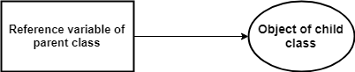](https://2.bp.blogspot.com/-lXV3bs63VIU/W2aSc7JpSLI/AAAAAAAAC-I/rRKhQkb8XP457DvtjoR6gmQX8_QD4l26wCLcBGAs/s1600/runtime-poly.png)**

When the reference variable of *Parent*class refers to the object of *Child*class, it is known as upcasting.

The method is overridden by not applicable data members, so runtime polymorphism can't be achieved by data members.

**Static Method in Interface**

Generally, static methods are used to define utility methods.

The idea behind static interface methods is to provide a simple mechanism that allows us to increase the degree of cohesion of a design by putting together related methods in one single place without having to create an object.

Furthermore, static methods in interfaces make possible to group related utility methods, without having to create artificial utility classes that are simply placeholders for static methods.

**Collections**:

ArrayList:

Based on Array Data structure

Allows null values and can contain duplicate elements.

Methods: add(), set(index, element), remove(), size(), get(), indexOf(“element”)

//Making ArrayList read only

List<String> readOnlyList= Collections.unmodifiableList(sports);

**Iterator Vs List Iterator:**

Iterator is used for entire collection framework.

List Iterator is only used for List interface.

[Iterator](https://www.geeksforgeeks.org/iterators-in-java/) can traverse only in forward direction whereas [ListIterator](https://www.geeksforgeeks.org/listiterator-in-java/) traverses both in forward and backward directions

**Fail-Fast and Fail Safe:**

CopyOnWriteArrayList, **ConcurrentHashMap** are fail safe as we can do list.remove and list.add()

Unlike the fail-fast iterators, **fail safe** iterators traverse over the clone of the collection. So even if the original collection gets structurally modified, no exception will be thrown.

1. The basic difference between Iterator and ListIterator is that both being cursor, Iterator can traverse elements in a collection only in forward direction. On the other hand, the ListIterator can traverse in both forward and backward directions.
2. Using iterator you can not add any element to a collection. But, by using ListIterator you can add elements to a collection.
3. Using Iterator, you can not remove an element in a collection where, as You can remove an element from a collection using ListIterator.
4. Using Iterator you can traverse all collections like Map, List, Set. But, by ListIteror you can traverse List implemented objects only.
5. You can retrieve an index of an element using Iterator. But as List is sequential and index-based you can retrieve an index of an element in using ListIterator.

***Note:****although it does not throw any exception, but the downsides of this iterator are:  
1. They will not reflect the latest state of the collection.  
2. It requires extra memory as it clones the collection.*

ArrayList al = new ArrayList(); for(int i=0; i<=10; i++){ al.add(i+1); } default capacity = 10 in the above example, we want to add 11 elements so new Capacity of ArrayList is int newCapacity = (oldcapacity\*3)/2+1 (10\*3)/2+1 = 16

ArrayList if we iterate it will support iterator.remove() but CopyOnWriteArrayList will not support iterator.remove() but will support list.remove();

* Initial Capacity:10
* Load Factor:1 (when the list is full)
* Growth Rate: current\_size + current\_size/2

**Vector:**

* Initial Capacity:10
* Load Factor:1 (when the list is full)
* Growth Rate: current\_size \* 2 (if capacityIncrement is not defined) current\_size + capacityIncrement (if capacityIncrement is defined during vector initialization)

**Linked List:**

Linked List is based on double linked list. So adding and removing is easy in LinkedList but searching is slow in LinkedList.

ArrayList is good for adding and searching purpose only.

**HashSet**:

* HashSet stores the elements by using a mechanism called **hashing.**
* HashSet contains unique elements only.
* HashSet allows null value.
* HashSet class is non synchronized.
* HashSet doesn't maintain the insertion order. Here, elements are inserted on the basis of their hash code.
* HashSet is the best approach for search operations.
* The initial default capacity of HashSet is 16, and the load factor is 0.75.

**LinkedHashSet:**

* Java LinkedHashSet class contains unique elements only like HashSet.
* Java LinkedHashSet class provides all optional set operations and permits null elements.
* Java LinkedHashSet class is non-synchronized.
* Java LinkedHashSet class maintains insertion order.

**HashMap**:

As the number of elements in the HashMap increases, the capacity is expanded.**The load factor is the measure that decides when to increase the capacity of the Map.** The default load factor is 75% of the capacity.

* Java HashMap contains values based on the key.
* Java HashMap contains only unique keys.
* Java HashMap may have one null key and multiple null values.
* Java HashMap is non synchronized.
* Java HashMap maintains no order.
* The initial default capacity of Java HashMap class is 16 with a load factor of 0.75.

Capacity is 16

A Map doesn't allow duplicate keys, but you can have duplicate values. HashMap and LinkedHashMap allow null keys and values, but TreeMap doesn't allow any null key or value.

HashMap and HashSet does not maintain order. HashMap

LinkedHashMap and LinkedHashSet maintains order

TreeMap and TreeSet gives sorted collection

1. map.entrySet()
2. //Returns a sequential Stream with this collection as its source
3. .stream()
4. //Sorted according to the provided Comparator
5. .sorted(Map.Entry.comparingByKey(Comparator.reverseOrder()))

 .sorted(Map.Entry.comparingByValue())

.sorted(Map.Entry.comparingByValue(Comparator.reverseOrder()))

**ConcurrentHashMap:**

* The underlined data structure for ConcurrentHashMap is [Hashtable](https://www.geeksforgeeks.org/hashtable-in-java/).
* ConcurrentHashMap class is thread-safe i.e. multiple threads can operate on a single object without any complications.
* At a time any number of threads are applicable for a read operation without locking the ConcurrentHashMap object which is not there in HashMap.
* In ConcurrentHashMap, the Object is divided into a number of segments according to the concurrency level.
* The default concurrency-level of ConcurrentHashMap is 16.
* In ConcurrentHashMap, at a time any number of threads can perform retrieval operation but for updated in the object, the thread must lock the particular segment in which the thread wants to operate. This type of locking mechanism is known as **Segment locking or bucket locking**. Hence at a time, 16 update operations can be performed by threads.
* Inserting null objects is not possible in ConcurrentHashMap as a key or value.
* **Concurrency-Level:**It is the number of threads concurrently updating the map. The implementation performs internal sizing to try to accommodate this many threads.
* **Load-Factor:** It’s a threshold, used to control resizing.
* **Initial Capacity:** Accommodation of a certain number of elements initially provided by the implementation. if the capacity of this map is 10. It means that it can store 10 entries.

**ConcurrentHashMap()**: Creates a new, empty map with a default initial capacity (16), load factor (0.75) and concurrencyLevel (16).

**BIG O Notation and Time Complexity:**

<https://gist.github.com/psayre23/c30a821239f4818b0709>

BIG O Notation and Time complexity are one way of describing how much time it takes to run a

function as the size of the input grows.

N 🡪 size of elements in given collection

**Time Complexity:** is a way of showing how much time it takes to complete a function or a particular piece of code as the size of the input increases.

3 types of time complexity: linear, constant, quadratic

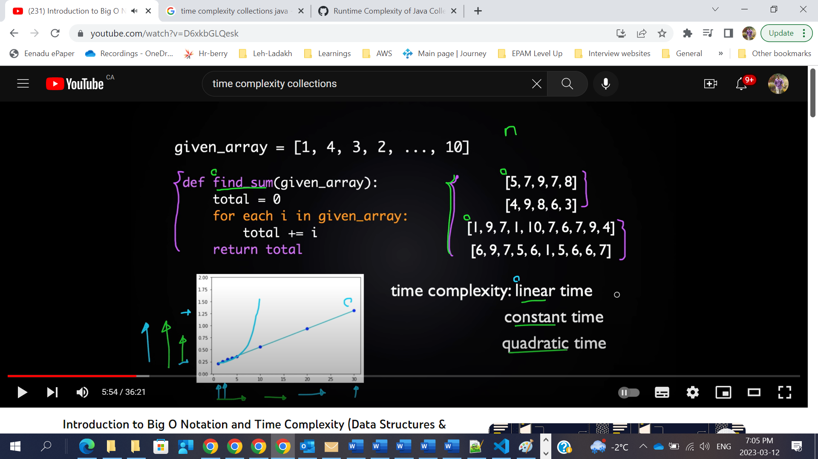

**Big O Notation:** Mathematical way of representing time complexity

Linear Time : O(n)

Constant Time: O(1)

Quadratic Time: O(n square)

**Equals and HashCode:**

By default equals() method uses “==” to compare the objects. So here “==” compares the reference addresses in java. If both objects refer to the same address then they are equal by default.

public native int hashCode();

Returns a hash code value for the object.

**If two objects have the same hashcode, do they equal each other?**

Not necessarily. As*hashcode()*returns a 32-bit integer, it is unavoidable that different objects could have the same hashcode value. A similar analogy could be that if two people have the same birthday, are they the same person?

**Or the other way around, if two objects are equal, do they have the same hashcode?**

Yes, they must have the same hashcode. Equal objects mean that they are referring to the same referenced object, which gives rise to the same hashcode.

https://medium.com/@pulapaphani/why-overriding-equals-and-hashcode-in-java-b5f869f985d2#:~:text=It%20needs%20to%20be%20overridden,override%20the%20equals()%20method.&text=Yes%2C%20now%20we%20are%20able%20achieve%20equality%20of%20objects.

**Two main points related to contract:**

*Equal objects must have equal hash codes.*

In HashSet, a HashMap is used to record the objects added to the set, with the key as the passed object and the value as a dummy new Object, shown by the source code:

private transient HashMap<E,Object> map;// Dummy value to associate with an Object in the backing Map  
private static final Object PRESENT = new Object();

public boolean add(E e) {  
 return map.put

(e, PRESENT)==null;  
}

HashMap and TreeMap and HashSet implementation:

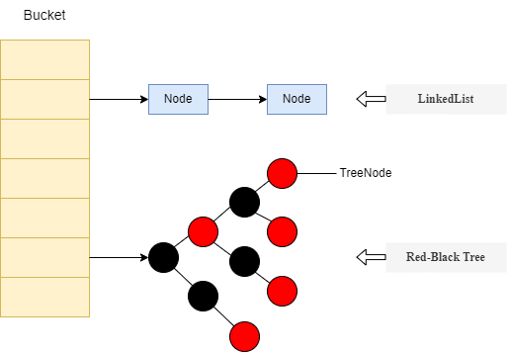

Java HashMap

When the length of the linked list is larger than or equal to 8 (TREEIFY\_THRESHOLD), the linked list will be converted to a [Red-Black tree](https://en.wikipedia.org/wiki/Red%E2%80%93black_tree). When the length decreases to 6 (UNTREEIFY\_THRESHOLD), it will be converted to a linked list. The time complexity of searching in a linked list is O(n) and the same for a red-black tree is O(log(n)).

## Put Function

public V put(K key, V value) {  
 return putVal(hash(key), key, value, false, true);  
}static final int hash(Object key) {  
 int h;  
 return (key == null) ? 0 : (h = key.hashCode()) ^ (h >>> 16);  
}

## Get Function

public V get(Object key) {  
 Node<K,V> e;  
 return (e = getNode(hash(key), key)) == null ? null : e.value;  
}

## Thoughts

Note that there are some common codes in the get() and put() functions. For example, when the key is passed, it will first obtain the hash of the key by calling hash() function. This is used in conjunction with (n-1) & hash to get the “bucket” position in the table.

Another part is that whenever to check for an existing value, HashMap will first compare the hash value and then the key reference/value.

<https://www.geeksforgeeks.org/internal-working-of-hashmap-java/>

Red-Black Tree for TreeMap implementation:

1. As the name of the algorithm suggests colour of every node in the tree is either black or red.
2. The root node must be Black in colour.
3. The red node can not have a red colour neighbours node.
4. All paths from the root node to the null should consist of the same number of black nodes.

The above characteristics lead to certain properties of a node to possess which results out as follows:

1. The left elements are always less than the parent element.
2. Natural ordering is computed in logical comparison of the objects.
3. The right elements are always greater than or equal to the parent element.

Collections Framework:

Collection is root interface and where as Collections is the utility class which provides few methods like sort(), reverse().

Java is statically typed language

Generics: why generics? To provide type safety.

Limitations of Array:

* Arrays are fixed in size.
* Arrays cant be used with Streams
* Arrays can be used to store only homogeneous elements
* There are no ready made data structures to store.

Collections is a group of individual objects as a single unit

**ArrayList**: **Default capacity of Arraylist is 10**

Java 8:

Method names:

Function, BiFunction 🡪 apply, andThen

Predicate -> test, andThen – returns boolean

BiPredicate -> test

Consumer, BiConsumer 🡪 accept() – accepts input but returns nothing

Supplier, BiSupplier 🡪 get() – accepts nothing but returns something

1. If any class in the hierarchy has a method with same signature, then default methods become irrelevant. A default method cannot override a method from java.lang.Object. The reasoning is very simple, it’s because Object is the base class for all the java classes. So even if we have Object class methods defined as default methods in interfaces, it will be useless because Object class method will always be used. That’s why to avoid confusion, we can’t have default methods that are overriding Object class methods.

Recursive vs Interation:

Wondering how many times the function can call itself?

The local variables and parameters being passed by value are newly created each time the function calls itself. They are stored in stack memory whenever a recursive call is made and are deallocated when the execution of the current function call is complete. The state of the functions is also stored in stack memory. Thus, each recursive call consumes some amount of memory on the stack. In case of infinite recursion or when recursion depth is large enough to exhaust the memory on the stack, it will cause a stack overflow error.

Iteration is faster and more space-efficient than recursion. So why do we even need recursion? The reason is simple — it's easier to code a recursive approach for a given problem

• There are O(N) recursive calls in our recursive approach, and each call uses O(1) operations. Thus, the time complexity of factorial using recursion is **O(N).**

• There are O(N) iterations of the loop in our iterative approach, so its time complexity is also O(N).

• Though both the programs’ theoretical time complexity is the same, a recursive program will take more time to execute due to the overhead of function calls, which is much higher than that of iteration.

**Space Complexity**

* In the recursive program, due to each recursive call, some memory gets allocated in the stack to store parameters and local variables. As there are O(N) recursive calls, the space complexity using recursion is **O(N).**
* No extra memory gets allocated in the iterative program, so its space complexity is O(1).

Java 8:

If you want to sort collection of custom objects then use Collections.sort using

Sample: Collections.*sort*(books, (Comparator.*comparing*(Book::getName)));

**Stream API:**

Stream API is used to process collection of objects. A stream is a sequence of objects that supports various methods which can be pipelined to produce the desired result.

Streams don’t change the original data structure, they only provide the result as per the pipelined methods.

Why we need Stream API:

* + 1. Functional Programming like Lambda expressions
    2. Code reduce—we can use method pipeline
    3. Bul operation

Java 9:

List.of(“Sai”,”Kiran”) – It creates unmodifiable list containing set of elements.

Java 10:

Local Variable Type Inference : var in Java

Java compiler infers the type of the variable at compile time.

## [Q5. Where can var be used?](https://openjdk.org/projects/amber/guides/lvti-faq#Q5)

var can be used for declaring local variables, including index variables of for-loops and resource variables of the try-with-resources statement.

var cannot be used for fields, method parameters, and method return types. The reason is that types in these locations appear explicitly in class files and in Javadoc specifications. With type inference, it’s quite easy for a change to an initializer to cause the variable’s inferred type to change. For local variables, this is not a problem, because local variables are limited in scope, and their types are not recorded directly into class files. However, type inference could easily cause a problem if types for fields, method parameters, and method return types were inferred.

List.copyOf

Java 11:

String: isBlank will give true even we have whitespace characters.

Predicate not

String:: strip()

String: lines()

### Local-Variable Syntax for Lambda

We can make use of this feature to apply modifiers to our local variables, like defining a type annotation:

List<String> sampleList = Arrays.asList("Java", "Kotlin");

**String** resultString = sampleList.stream()

.map((@Nonnull **var** x) -> x.toUpperCase())

.collect(Collectors.joining(", "));

assertThat(resultString).isEqualTo("JAVA, KOTLIN");

### A No-Op Garbage Collector

A new garbage collector called Epsilon is available for use in Java 11 as an experimental feature.

It's called a No-Op (no operations) because it allocates memory but does not actually collect any garbage. Thus, Epsilon is applicable for simulating out of memory errors.

Java 12:

Updates in switch statement in Preview

String: transform method

Java 13:

String formatted

Java 14:

**Foreign-Memory Access API:** Java 14 introduced a Foreign-Memory Access API, which allows Java code to safely and efficiently access foreign memory outside of the Java heap. This feature is particularly useful for memory-intensive applications and for interfacing with other systems and languages. [Details](https://openjdk.org/jeps/370)

Switch Expression is in preview mode in 12 and 13 and made final in Java 14.

**Records are immutable data classes that require only the type and name of fields.**

1. *private*, *final* field for each piece of data
2. getter for each field
3. *public* constructor with a corresponding argument for each field
4. *equals* method that returns *true* for objects of the same class when all fields match
5. *hashCode* method that returns the same value when all fields match
6. *toString* method that includes the name of the class and the name of each field and its corresponding value

* Detailed description of NullPointerException
* 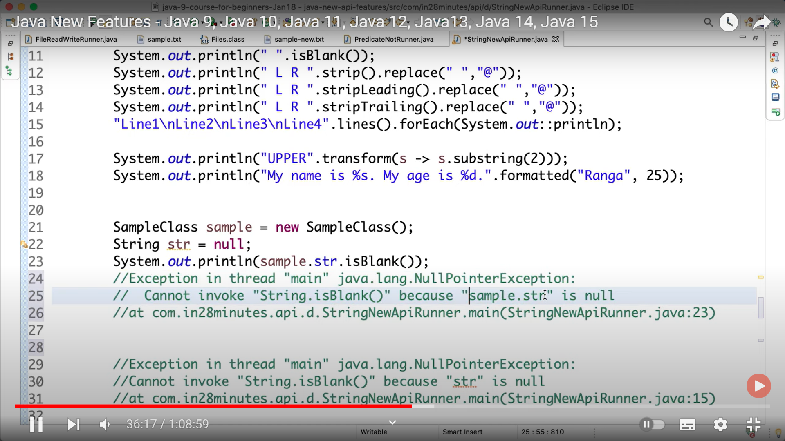

Java 15:

Multi line Strings: Preview in 13 and 14 and Released in 15

String textBlock = """

Hi

Hello

Yes""";

Java 21:

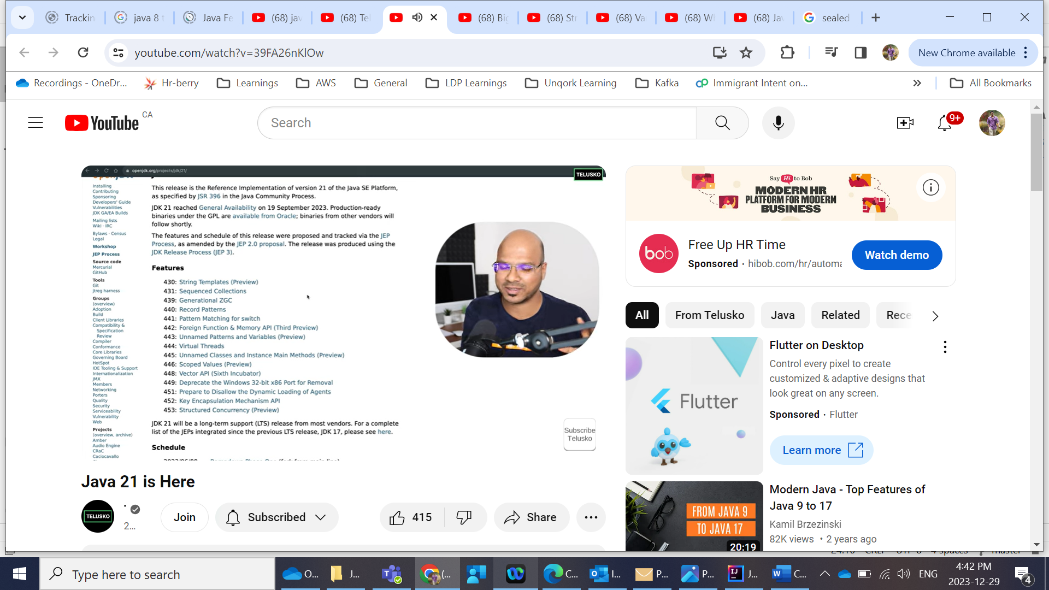

SOLID Principles:

https://www.baeldung.com/solid-principles

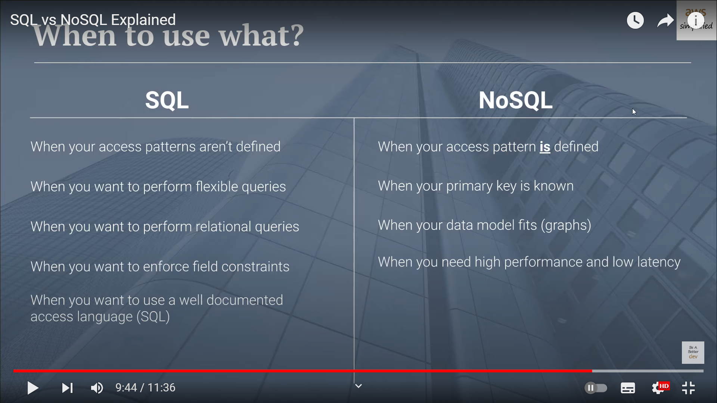

**Splunk**:

## What Is Distributed Tracing, And How Can It Help My Microservice Deployment?

Distributed tracing follows a request (transaction) as it moves between multiple services within a microservices architecture allowing engineers to help identify where the service request originates from (user-facing frontend application) throughout its journey with other services. This type of visibility allows DevOps engineers to identify issues quickly, affecting application performance.

<https://medium.com/javarevisited/distributed-tracing-in-microservices-spring-boot-125272b58ad8>

https://medium.com/@reddy.srikant/logging-configuration-in-spring-boot-for-splunk-e6b504658011

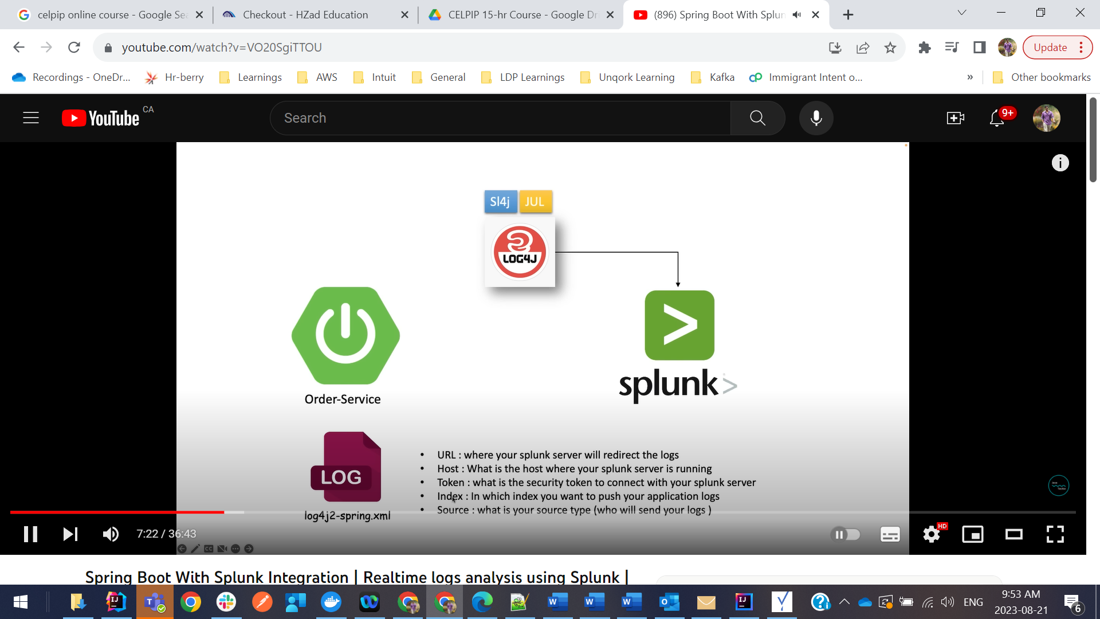

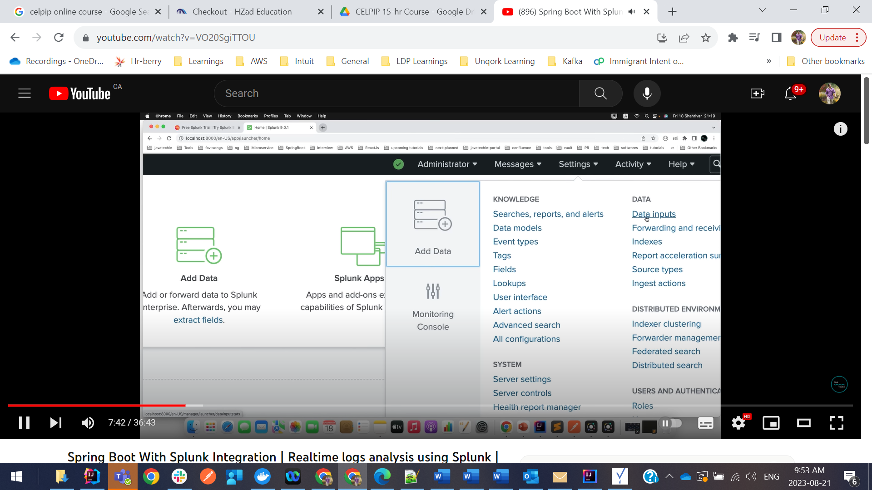

Then select Http event collector:

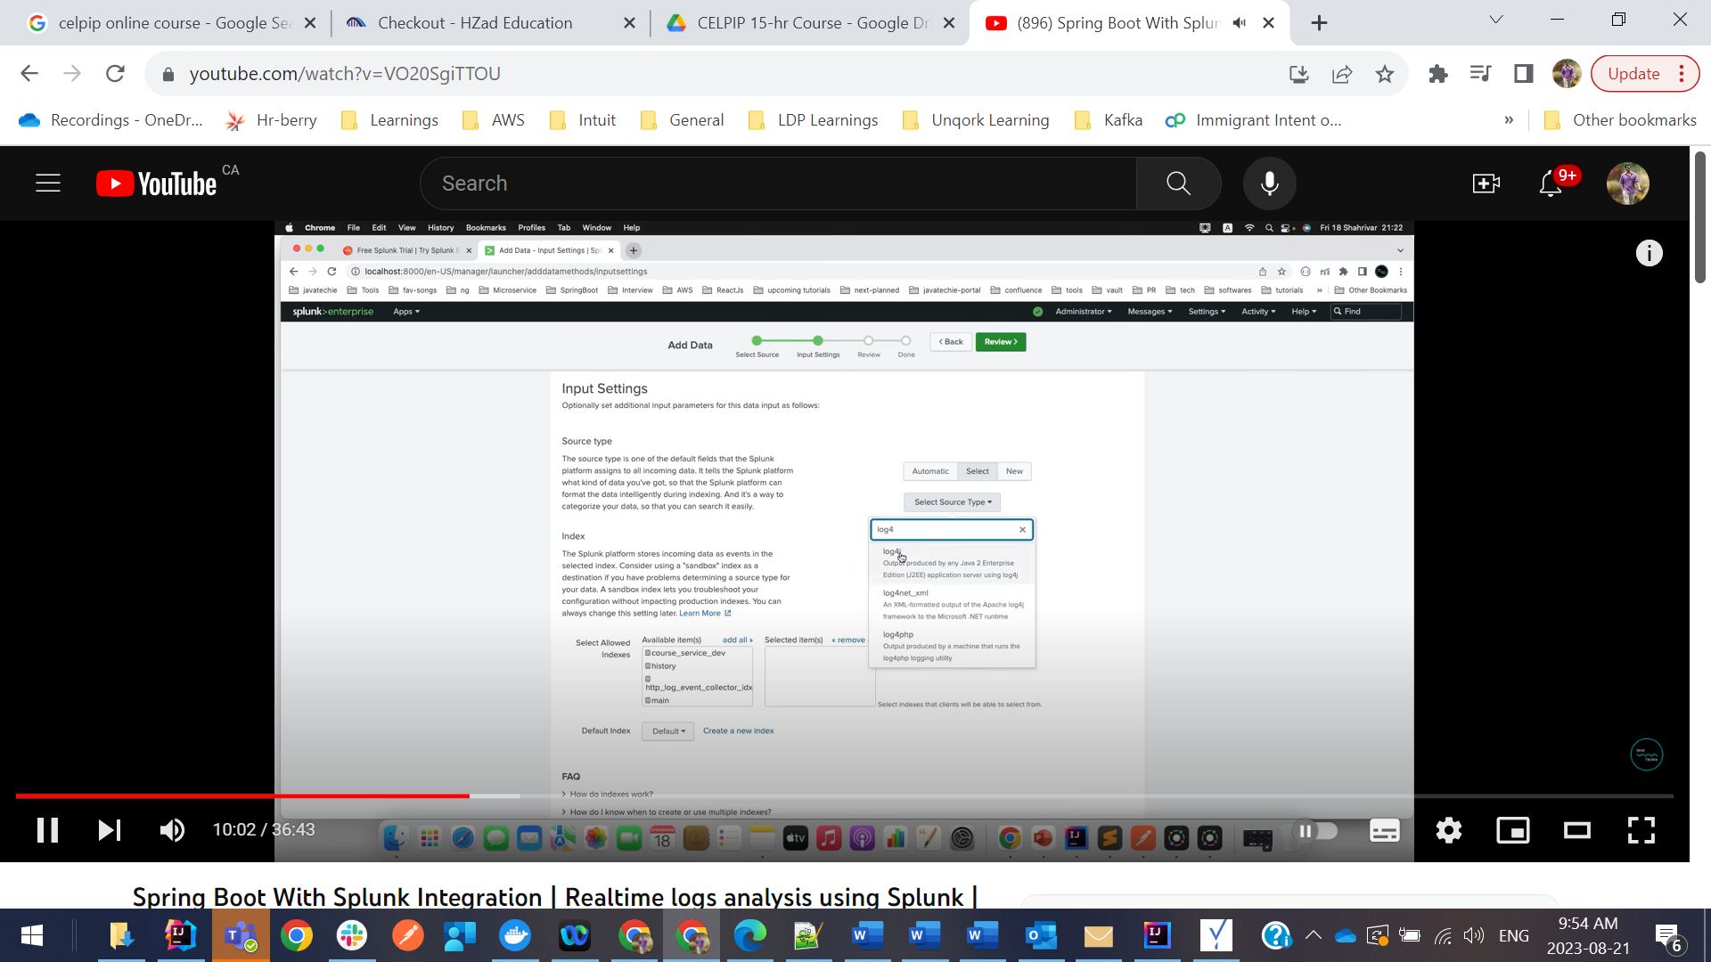

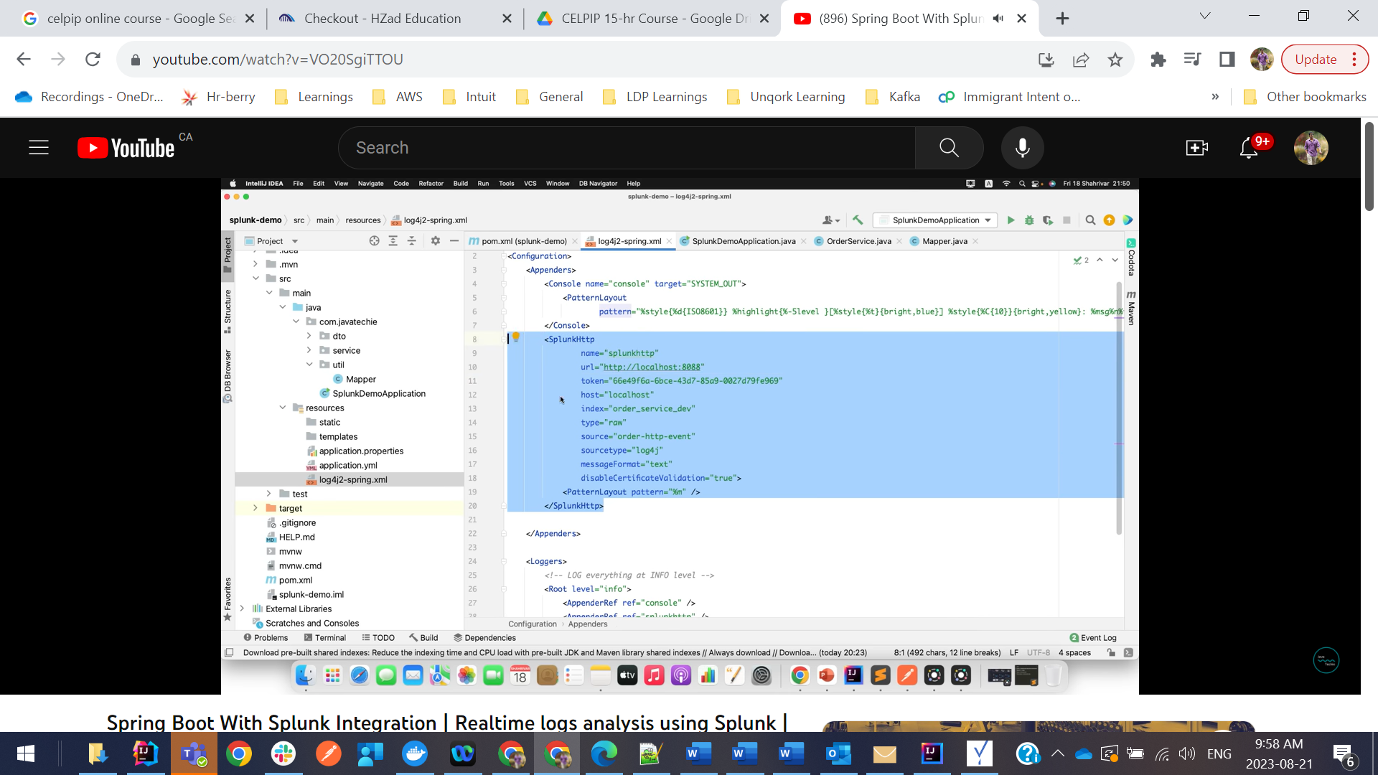

Index=”order-service-dev”

Index=” order-service-dev” AND (EXCEPTION or ERROR)

**Splunk Alert System:**

We are dependent on third party API to get real time available shares so we created Alert system when that API is down.

Spring boot exception handler sample code:

package com.intuit.data.persistplat.dppselfserviceapp.v1.advice;  
  
import com.google.common.collect.ImmutableSet;  
import com.google.common.collect.MoreCollectors;  
import com.intuit.cto.dpp.selfservice.common.validation.ValidationException;  
import com.intuit.cto.dpp.selfservice.persistence.error.CompositionNotFoundException;  
import com.intuit.cto.dpp.selfservice.persistence.error.DataStewardsNotFoundException;  
import com.intuit.cto.dpp.selfservice.persistence.error.EntitiesAlreadyApprovedException;  
import com.intuit.cto.dpp.selfservice.persistence.error.EntityTypeNot7216Error;  
import com.intuit.cto.dpp.selfservice.persistence.error.InProgressReleaseFoundException;  
import com.intuit.cto.dpp.selfservice.persistence.error.InvalidDeploymentEnvironmentException;  
import com.intuit.cto.dpp.selfservice.persistence.error.DataMapNotFoundException;  
import com.intuit.cto.dpp.selfservice.persistence.error.ReleaseException;  
import com.intuit.cto.dpp.selfservice.persistence.error.ReleaseNotFoundException;  
import com.intuit.cto.dpp.selfservice.persistence.error.RollbackException;  
import com.intuit.cto.dpp.selfservice.persistence.error.UpdateFailedException;  
import com.intuit.data.persistplat.dppselfserviceapp.v1.error.DuplicateEntryException;  
import com.intuit.data.persistplat.dppselfserviceapp.v1.error.ErrorCode;  
import com.intuit.data.persistplat.dppselfserviceapp.v1.error.InvalidInputException;  
import com.intuit.data.persistplat.dppselfserviceapp.v1.error.ResourceNotFoundException;  
import com.intuit.data.persistplat.dppselfserviceapp.v1.model.response.ErrorResponse;  
import com.intuit.data.persistplat.security.exception.AuthenticationException;  
import com.intuit.data.persistplat.security.exception.AuthorizationException;  
import org.slf4j.Logger;  
import org.springframework.beans.factory.annotation.Autowired;  
import org.springframework.http.HttpStatus;  
import org.springframework.http.converter.HttpMessageNotReadableException;  
import org.springframework.security.access.AccessDeniedException;  
import org.springframework.validation.annotation.Validated;  
import org.springframework.web.HttpRequestMethodNotSupportedException;  
import org.springframework.web.bind.MethodArgumentNotValidException;  
import org.springframework.web.bind.MissingServletRequestParameterException;  
import org.springframework.web.bind.annotation.ControllerAdvice;  
import org.springframework.web.bind.annotation.ExceptionHandler;  
import org.springframework.web.bind.annotation.ResponseBody;  
import org.springframework.web.bind.annotation.ResponseStatus;  
import org.springframework.web.context.request.ServletWebRequest;  
import org.springframework.web.method.annotation.MethodArgumentTypeMismatchException;  
import org.springframework.web.servlet.NoHandlerFoundException;  
  
import javax.annotation.Nullable;  
import javax.validation.constraints.NotNull;  
import java.util.Arrays;  
import java.util.List;  
import java.util.Optional;  
import java.util.stream.Collectors;  
  
@Validated  
@ControllerAdvice  
public class RestExceptionHandler {  
 private final Logger logger;  
  
 @Autowired  
 public RestExceptionHandler(final Logger logger) {  
 this.logger = logger;  
 }  
  
 @Nullable  
 private static String getTid(@NotNull final ServletWebRequest servletWebRequest) {  
 return Optional.*ofNullable*(servletWebRequest.getResponse()).flatMap(  
 httpServletResponse -> httpServletResponse  
 .getHeaderNames()  
 .parallelStream()  
 .filter("intuit\_tid"::equalsIgnoreCase)  
 .map(httpServletResponse::getHeader)  
 .collect(MoreCollectors.*toOptional*()))  
 .orElse(null);  
 }  
  
 @ResponseBody  
 @ResponseStatus(HttpStatus.*NOT\_FOUND*)  
 @ExceptionHandler(NoHandlerFoundException.class)  
 public ErrorResponse handleNotFoundError(final NoHandlerFoundException e, final ServletWebRequest servletWebRequest) {  
 final String requestPath = servletWebRequest.getRequest().getServletPath();  
 return ErrorResponse.*builder*()  
 .path(requestPath)  
 .code(ErrorCode.*NOT\_FOUND*)  
 .error("Not found")  
 .details(String.*format*("Resource %s not found", requestPath))  
 .tid(*getTid*(servletWebRequest))  
 .build();  
 }  
  
 @ResponseBody  
 @ResponseStatus(HttpStatus.*UNAUTHORIZED*)  
 @ExceptionHandler(AuthenticationException.class)  
 public ErrorResponse handleAuthenticationError(final AuthenticationException e, final ServletWebRequest servletWebRequest) {  
 logger.warn("Authentication error", e);  
 return ErrorResponse.*builder*()  
 .path(servletWebRequest.getRequest().getServletPath())  
 .code(ErrorCode.*UNAUTHENTICATED*)  
 .error("Authentication failed")  
 .details(e.getMessage())  
 .tid(*getTid*(servletWebRequest))  
 .build();  
 }  
  
 @ResponseBody  
 @ResponseStatus(HttpStatus.*FORBIDDEN*)  
 @ExceptionHandler({AuthorizationException.class, AccessDeniedException.class})  
 public ErrorResponse handleAuthorizationError(final Exception e, final ServletWebRequest servletWebRequest) {  
 logger.warn("Authorization error", e);  
 return ErrorResponse.*builder*()  
 .path(servletWebRequest.getRequest().getServletPath())  
 .code(ErrorCode.*UNAUTHORIZED*)  
 .error("Authorization failed")  
 .details(e.getMessage())  
 .tid(*getTid*(servletWebRequest))  
 .build();  
 }  
  
 @ResponseBody  
 @ResponseStatus(HttpStatus.*METHOD\_NOT\_ALLOWED*)  
 @ExceptionHandler(HttpRequestMethodNotSupportedException.class)  
 public ErrorResponse handleMethodNotAllowedError(final HttpRequestMethodNotSupportedException e, final ServletWebRequest servletWebRequest) {  
 return ErrorResponse.*builder*()  
 .path(servletWebRequest.getRequest().getServletPath())  
 .code(ErrorCode.*METHOD\_NOT\_ALLOWED*)  
 .error("Method not allowed")  
 .details(e.getMessage())  
 .tid(*getTid*(servletWebRequest))  
 .build();  
 }  
  
  
 @ResponseBody  
 @ResponseStatus(HttpStatus.*BAD\_REQUEST*)  
 @ExceptionHandler(ValidationException.class)  
 public ErrorResponse handleValidationException(final ValidationException e, final ServletWebRequest servletWebRequest) {  
 List<String> moreDetails = Arrays.*stream*(e.getSuppressed()).map( suppressed -> suppressed.getMessage() ).collect(Collectors.*toList*());  
 return ErrorResponse.*builder*()  
 .path(servletWebRequest.getRequest().getServletPath())  
 .code(ErrorCode.*INVALID\_INPUT*)  
 .error("Validation Exception")  
 .details(e.getMessage())  
 .moreDetails(moreDetails)  
 .note(e.getNote())  
 .tid(*getTid*(servletWebRequest))  
 .build();  
 }  
  
 @ResponseBody  
 @ResponseStatus(HttpStatus.*BAD\_REQUEST*)  
 @ExceptionHandler({InvalidInputException.class, MethodArgumentNotValidException.class, HttpMessageNotReadableException.class, DuplicateEntryException.class})  
 public ErrorResponse handleInputError(final Exception e, final ServletWebRequest servletWebRequest) {  
 return ErrorResponse.*builder*()  
 .path(servletWebRequest.getRequest().getServletPath())  
 .code(ErrorCode.*INVALID\_INPUT*)  
 .error("Invalid input")  
 .details(e.getMessage())  
 .tid(*getTid*(servletWebRequest))  
 .build();  
 }  
  
 @ResponseBody  
 @ResponseStatus(HttpStatus.*BAD\_REQUEST*)  
 @ExceptionHandler(MethodArgumentTypeMismatchException.class)  
 public ErrorResponse handleMethodArgumentTypeMismatch(final MethodArgumentTypeMismatchException e, final ServletWebRequest servletWebRequest) {  
 final Class<?> requiredType = e.getRequiredType();  
  
 final String requiredTypeAdditionalDetails = requiredType != null && Enum.class.isAssignableFrom(requiredType)  
 ? String.*format*(" (Accepted values: %s)", ImmutableSet.*copyOf*(requiredType.getEnumConstants()))  
 : "";  
  
 return ErrorResponse.*builder*()  
 .path(servletWebRequest.getRequest().getServletPath())  
 .code(ErrorCode.*INVALID\_INPUT*)  
 .error("Input type mismatch")  
 .details(String.*format*("Cannot convert value %s to type %s%s", e.getValue(), requiredType, requiredTypeAdditionalDetails))  
 .tid(*getTid*(servletWebRequest))  
 .build();  
 }  
  
 @ResponseBody  
 @ResponseStatus(HttpStatus.*BAD\_REQUEST*)  
 @ExceptionHandler(MissingServletRequestParameterException.class)  
 public ErrorResponse handleMissingUrlParameter(final MissingServletRequestParameterException e, final ServletWebRequest servletWebRequest) {  
 return ErrorResponse.*builder*()  
 .path(servletWebRequest.getRequest().getServletPath())  
 .code(ErrorCode.*INVALID\_INPUT*)  
 .error("Missing required URL parameter")  
 .details(String.*format*("Missing URL parameter %s", e.getParameterName()))  
 .tid(*getTid*(servletWebRequest))  
 .build();  
 }  
  
 @ResponseBody  
 @ResponseStatus(HttpStatus.*INTERNAL\_SERVER\_ERROR*)  
 @ExceptionHandler(Exception.class)  
 public ErrorResponse handleServerError(final Exception e, final ServletWebRequest servletWebRequest) {  
 logger.error("Uncaught exception", e);  
 return ErrorResponse.*builder*()  
 .code(ErrorCode.*INTERNAL\_SERVER\_ERROR*)  
 .error("Internal server error")  
 .details(e.getMessage())  
 .tid(*getTid*(servletWebRequest))  
 .build();  
 }  
  
 @ResponseBody  
 @ResponseStatus(HttpStatus.*NOT\_FOUND*)  
 @ExceptionHandler(ResourceNotFoundException.class)  
 public ErrorResponse handleResourceNotFoundError(final ResourceNotFoundException e, final ServletWebRequest servletWebRequest) {  
 final String requestPath = servletWebRequest.getRequest().getServletPath();  
 return ErrorResponse.*builder*()  
 .path(requestPath)  
 .code(ErrorCode.*NOT\_FOUND*)  
 .error("Not found")  
 .details(e.getMessage())  
 .tid(*getTid*(servletWebRequest))  
 .build();  
 }  
  
 @ResponseBody  
 @ResponseStatus(HttpStatus.*NOT\_MODIFIED*)  
 @ExceptionHandler(UpdateFailedException.class)  
 public ErrorResponse handleUpdateFailed(final UpdateFailedException e, final ServletWebRequest servletWebRequest) {  
 final String requestPath = servletWebRequest.getRequest().getServletPath();  
 return ErrorResponse.*builder*()  
 .path(requestPath)  
 .code(ErrorCode.*INTERNAL\_SERVER\_ERROR*)  
 .error("Update failed")  
 .details(e.getMessage())  
 .tid(*getTid*(servletWebRequest))  
 .build();  
 }  
  
 @ResponseBody  
 @ResponseStatus(HttpStatus.*BAD\_REQUEST*)  
 @ExceptionHandler(InProgressReleaseFoundException.class)  
 public ErrorResponse handleInProgressReleaseFoundException(final InProgressReleaseFoundException e, final ServletWebRequest servletWebRequest) {  
 final String requestPath = servletWebRequest.getRequest().getServletPath();  
 return ErrorResponse.*builder*()  
 .path(requestPath)  
 .code(ErrorCode.*BAD\_REQUEST*)  
 .error("Release Found Exception")  
 .details(e.getMessage())  
 .tid(*getTid*(servletWebRequest))  
 .build();  
 }  
  
 @ResponseBody  
 @ResponseStatus(HttpStatus.*BAD\_REQUEST*)  
 @ExceptionHandler(DataStewardsNotFoundException.class)  
 public ErrorResponse dataStewardFoundException(final DataStewardsNotFoundException e, final ServletWebRequest servletWebRequest) {  
 final String requestPath = servletWebRequest.getRequest().getServletPath();  
 return ErrorResponse.*builder*()  
 .path(requestPath)  
 .code(ErrorCode.*BAD\_REQUEST*)  
 .error("Data Steward Not Found for asset")  
 .details(e.getMessage())  
 .tid(*getTid*(servletWebRequest))  
 .build();  
 }  
  
 @ResponseBody  
 @ResponseStatus(HttpStatus.*BAD\_REQUEST*)  
 @ExceptionHandler(DataMapNotFoundException.class)  
 public ErrorResponse dataStewardFoundException(final DataMapNotFoundException e, final ServletWebRequest servletWebRequest) {  
 final String requestPath = servletWebRequest.getRequest().getServletPath();  
 return ErrorResponse.*builder*()  
 .path(requestPath)  
 .code(ErrorCode.*BAD\_REQUEST*)  
 .error("Recipe Not Found")  
 .details(e.getMessage())  
 .tid(*getTid*(servletWebRequest))  
 .build();  
 }  
  
 @ResponseBody  
 @ResponseStatus(HttpStatus.*BAD\_REQUEST*)  
 @ExceptionHandler(ReleaseNotFoundException.class)  
 public ErrorResponse handleReleaseNotFoundException(final ReleaseNotFoundException e, final ServletWebRequest servletWebRequest) {  
 final String requestPath = servletWebRequest.getRequest().getServletPath();  
 return ErrorResponse.*builder*()  
 .path(requestPath)  
 .code(ErrorCode.*BAD\_REQUEST*)  
 .error("Release Not Found Exception")  
 .details(e.getMessage())  
 .tid(*getTid*(servletWebRequest))  
 .build();  
 }  
  
 @ResponseBody  
 @ResponseStatus(HttpStatus.*INTERNAL\_SERVER\_ERROR*)  
 @ExceptionHandler(ReleaseException.class)  
 public ErrorResponse handleReleaseException(final ReleaseNotFoundException e, final ServletWebRequest servletWebRequest) {  
 final String requestPath = servletWebRequest.getRequest().getServletPath();  
 return ErrorResponse.*builder*()  
 .path(requestPath)  
 .code(ErrorCode.*INTERNAL\_SERVER\_ERROR*)  
 .error("Release Exception")  
 .details(e.getMessage())  
 .tid(*getTid*(servletWebRequest))  
 .build();  
 }  
  
 @ResponseBody  
 @ResponseStatus(HttpStatus.*BAD\_REQUEST*)  
 @ExceptionHandler(EntitiesAlreadyApprovedException.class)  
 public ErrorResponse handleEntitiesAlreadyException(final EntitiesAlreadyApprovedException e, final ServletWebRequest servletWebRequest) {  
 return ErrorResponse.*builder*()  
 .path(servletWebRequest.getRequest().getServletPath())  
 .code(ErrorCode.*INVALID\_INPUT*)  
 .error("Invalid input")  
 .details(e.getMessage())  
 .moreDetails(e.getMoreDetails())  
 .tid(*getTid*(servletWebRequest))  
 .build();  
 }  
  
 @ResponseBody  
 @ResponseStatus(HttpStatus.*BAD\_REQUEST*)  
 @ExceptionHandler(CompositionNotFoundException.class)  
 public ErrorResponse compositionNotFoundException(final CompositionNotFoundException e, final ServletWebRequest servletWebRequest) {  
 return ErrorResponse.*builder*()  
 .path(servletWebRequest.getRequest().getServletPath())  
 .code(ErrorCode.*INVALID\_INPUT*)  
 .error("Invalid input")  
 .details(e.getMessage())  
 .moreDetails(e.getMoreDetails())  
 .tid(*getTid*(servletWebRequest))  
 .build();  
 }  
  
 @ResponseBody  
 @ResponseStatus(HttpStatus.*BAD\_REQUEST*)  
 @ExceptionHandler(InvalidDeploymentEnvironmentException.class)  
 public ErrorResponse invalidDeploymentEnvironmentException(final InvalidDeploymentEnvironmentException e, final ServletWebRequest servletWebRequest) {  
 return ErrorResponse.*builder*()  
 .path(servletWebRequest.getRequest().getServletPath())  
 .code(ErrorCode.*INVALID\_INPUT*)  
 .error("Invalid input")  
 .details(e.getMessage())  
 .moreDetails(e.getMoreDetails())  
 .tid(*getTid*(servletWebRequest))  
 .build();  
 }  
  
 @ResponseBody  
 @ResponseStatus(HttpStatus.*BAD\_REQUEST*)  
 @ExceptionHandler(RollbackException.class)  
 public ErrorResponse rollbackException(final RollbackException e, final ServletWebRequest servletWebRequest) {  
 return ErrorResponse.*builder*()  
 .path(servletWebRequest.getRequest().getServletPath())  
 .code(ErrorCode.*INVALID\_INPUT*)  
 .error("Invalid input")  
 .details(e.getMessage())  
 .moreDetails(e.getMoreDetails())  
 .tid(*getTid*(servletWebRequest))  
 .build();  
 }  
  
 @ResponseBody  
 @ResponseStatus(HttpStatus.*BAD\_REQUEST*)  
 @ExceptionHandler(EntityTypeNot7216Error.class)  
 public ErrorResponse handleEntitiesTypeNot7216Exception(final EntityTypeNot7216Error e, final ServletWebRequest servletWebRequest) {  
 return ErrorResponse.*builder*()  
 .path(servletWebRequest.getRequest().getServletPath())  
 .code(ErrorCode.*INVALID\_INPUT*)  
 .error("Invalid input")  
 .details(e.getMessage())  
 .moreDetails(e.getMoreDetails())  
 .tid(*getTid*(servletWebRequest))  
 .build();  
 }  
  
}

**Executor Framework:**

* It used Thread pools and we don’t need to work with low level methods from Thread API
* It helps in proper resource utilization and we don’t need to create new thread every time using new Thread and also no need to start using start() method.
* It decouples task submission from thread creation and management.
* Each thread in the pool executes multiple tasks one by one.
* Shutdown() and shutdownNow() methods
* Executor Interface: void execute(Runnable task)
* ExecutorService Interface: it extends Executor and provides life cycle to the executor
* Callable Interface: When we submit a task and expects results then we use Callable, if we don’t expect any result then we can use Runnable.
* Executors: It is a factory class with static methods that constructs and returns various kinds of instances of ExecutorService with commonly used configuration settings
* Public static ExecutorService newFixedThreadPool(int nThreads)
* Public static ExecutorService newCachedThreadPool()
* Public static ExecutorService newSingleThreadExecutor()
* Public static ExecutorService newSingleThreadScheduledExecutor()
* If you want some tasks to be executed sequentially then use newSingleThreadExecutor() as not more than one task will be executed at the same time.
* Whenever you submit any callable the executorservice returns an instance of Future instance
* Get() method should be called to get the value and this call gets blocked until the response comes.

**Callable Interface:**

It has one abstract method: V call() throws Exception; It returns something called Future.

**Future:**

A Future represents the result of an asynchronous computation. Methods are provided to check if the computation is complete, to wait for its completion, and to retrieve the result of the computation. The result can only be retrieved using method get when the computation has completed, blocking if necessary until it is ready. Cancellation is performed by the cancel method.

The advantages of using a Future are enormous because we could do some very intensive computation asynchronously without blocking the current thread that in the meantime can do some other useful job.

**CompletableFuture**:

Reactive Streams are **push-based** and Java 8 Streams are **pull based**.

*A client that initiates a request, doesn’t get blocked with Mono and Flux. The corresponding request thread goes back into the thread pool. Once the result of the long-running operation is available, it will be pushed to the client.*

Pending Question: CompletableFuture vs Streams parallel:

CompletableFuture.supplyAsync() will end up using a ForkJoinPool initialized with parralelism of Runtime.getRuntime().availableProcessors() - 1 ([JDK 11 source](https://hg.openjdk.java.net/jdk/jdk11/file/1ddf9a99e4ad/src/java.base/share/classes/java/util/concurrent/ForkJoinPool.java#l2358))

So looks like you have an 8 processor machine. Therefore there are 7 threads in the pool.

There are 8 API calls, so only 7 can run at a time on the common pool. And for the completable futures test, there will be 8 tasks running with your main thread blocking until they all complete. 7 will be able to execute at once meaning one has to wait for 4 seconds.

parallelStream() also uses this same thread pool, however the difference is that the first task will be executed on main thread that is executing the stream's terminal operation, leaving 7 to be distributed to the common pool. So there are just enough threads to run everything in parallel in this scenario. Try increasing the number of tasks to 9 and you will get the 8 second run-time for your test.

CompletableFuture uses Threadpool to achieve asynchronous programming. By default it will take threads from ForkJoinPool if we don’t provide any Threadpool.

Using Asynchronous programming you can write non blocking code where concurrently you can run N number of tasks in separate threads without blocking main thread. When the task is complete it will notify the main thread. We can use CompletableFuture to achieve asynchronous programming in Java.

* We have Future, ThreadPool, ExecutorService and Callable Interfaces to achieve asynchronous programming in Java then

**Why CompletableFuture is more useful than above:**

* Future cannot be manually completed means we cannot force it to complete.
* Multiple futures cannot be chained together.
* We cannot combine multiple futures together.
* No Proper Exception Handling Mechanism.

Interview Question:

What is the difference between ExecutorService.submit() and ExecutorService.execute() – submit accepts Callable and returns Future and execute accepts Runnable and returns nothing.

How to decide number of threads in Threadpool? It depends on two factors.

* 1. Number of processors
  2. Number or Kind of Tasks: -- CPU Bound/CPU Intensive

**runAsync vs supplyAsync:**

If we want to run some background task asynchronously and we do not expecting anything back from that task then we can use runAsync

CompletableFuture<void> runAsync(Runnable)

runAynsc(Runnable, Executor)

* If we don’t give Executor, CompletableFuture will get Thread from ForkJoinPool
* **ForkJoinPool:** Returns the common pool instance. This pool is statically constructed; its run state is unaffected by attempts to shutdown or shutdownNow. However this pool and any ongoing processing are automatically terminated upon program System.exit. Any program that relies on asynchronous task processing to complete before program termination should invoke commonPool().awaitQuiescence, before exit.

If we want to run some background task asynchronously and expecting anything back from that task then use supplyAsync

CompletableFuture.supplyAsync(Supplier<T>)

CompletableFuture.supplyAsync(Supplier<T>, Executor)

*//The Void class is an uninstantiable placeholder class to hold a  
 // reference to the Class object representing the Java keyword void.  
 // public static final Class<Void> TYPE = (Class<Void>) Class.getPrimitiveClass("void");*

* thenApply(Function) – It will accept the Function so it is used to transform the data.
* thenAccept(Consumer) – It will take arguments but does not return anything.
* theRun(Runnable) – thenRun accepts Runnable and it just performs an action.
* What is the difference between thenApply and thenComposeAsyc() (pending Question)
* Difference between thenapply() and thenapplyasync() (pending Question)
* Difference between thenrun() and thenaccept() (pending Question)
* future.thenApply(result -> result.toUpperCase())
* .thenAccept(result -> System.out.println("Result: " + result))
* .thenRun(() -> System.out.println("Operation Completed."));
* # Output:
* # 'Result: HELLO COMPLETABLEFUTURE'
* # 'Operation Completed.'
* Java
* Copy
* In this example, thenApply is used to transform the result to uppercase. **thenAccept is then used to consume the result, in this case, by printing it. Finally, thenRun is used to execute a Runnable once the computation is done. It doesn’t consume the result; instead, it simply performs an action.**

package org.example.threadingandexecutor;  
  
import java.util.concurrent.CompletableFuture;  
  
public class ParallelCallsUsingCompletableFuture {  
 public static void main(String[] args) {  
 CompletableFuture<String> future1 = CompletableFuture.*supplyAsync*(() -> {  
 *// Some long-running operation* System.*out*.println("Thread name in first future is "+Thread.*currentThread*().getName());  
 return "Result 1";  
 });  
  
 CompletableFuture<String> future2 = CompletableFuture.*supplyAsync*(() -> {  
 *// Some long-running operation* System.*out*.println("Thread name in second future is "+Thread.*currentThread*().getName());  
 return "Result 2";  
 });  
  
 CompletableFuture<String> future3 = CompletableFuture.*supplyAsync*(() -> {  
 *// Some long-running operation* System.*out*.println("Thread name in third future is "+Thread.*currentThread*().getName());  
 return "Result 3";  
 });  
  
 CompletableFuture<Void> allFutures = CompletableFuture.*allOf*(future1, future2, future3);  
  
 allFutures.thenRun(() -> {  
 *// All futures completed* String result1 = future1.join();  
 String result2 = future2.join();  
 String result3 = future3.join();  
 System.*out*.println(result1 + ", " + result2 + ", " + result3);  
 });  
 }  
}

**Synchronous Vs Asynchronous**:

### A synchronous example

Here we have a HTTP endpoint that the handles a request synchronously.

@RequestMapping(path = "/sync", method = RequestMethod.GET)

public String getValueSync() {

log.info("Request received");

return processRequest();

}

This generates the following log output…

21:21:19.204 [ main] Before request

21:21:19.347 [http-nio-auto-1-exec-1] Request received

21:21:19.347 [http-nio-auto-1-exec-1] Start processing request

21:21:24.351 [http-nio-auto-1-exec-1] Completed processing request

21:21:24.374 [ main] After request

The key thing to note here is that all processing occurs on the same HTTP thread (http-nio-auto-1-exec-1). This means that for the duration of the request the HTTP thread is blocked and unavailable to serve other requests made to the system. This is undesirable due to the potential for the servlet container’s thread pool to be exhausted when an app is under heavy load thus impacting an apps scalability.

### An asynchronous example using CompletableFuture

Finally we have a HTTP endpoint that handles a request asynchronously using Java 8’s CompletableFuture.

@RequestMapping(path = "/asyncCompletable", method = RequestMethod.GET)

public CompletableFuture<String> getValueAsyncUsingCompletableFuture() {

log.info("Request received");

CompletableFuture<String> completableFuture =

CompletableFuture.supplyAsync(this::processRequest);

log.info("Servlet thread released");

return completableFuture;

}

This generates the following log output…

21:21:29.453 [ main] Before request

21:21:29.456 [http-nio-auto-1-exec-4] Request received

21:21:29.458 [http-nio-auto-1-exec-4] Servlet thread released

21:21:29.458 [ForkJoinPool.commonPool-worker-1] Start processing request

21:21:34.463 [ForkJoinPool.commonPool-worker-1] Completed processing request

21:21:34.468 [ main] After request

The result is pretty much identical to the DeferredResult example in that the request processing occurs on a different thread. It’s worth noting that this example also uses the ForkJoinPool due it being the default when no explicit thread pool is provided to the supplyAsync method.

When we run this code, it will start all three futures in parallel and then wait for them to complete before printing the results. The order of the results may vary depending on which future completes first, but all three results will be printed to the console once they are all available.

Overall Theory:

* In traditional web requests, web server handles request and assign a new thread for every request. Lets say in this request there is a DB call to fetch data and request thread hands over this task to DB driver and this thread goes into waiting state and does nothing which is under utilization of CPU resources and these threads gets blocked until the request is completed. So this way performance is very slow as all web server will soon gets exhausted with Threads. And to increase these thread count we increase servers or size of the server.
* Next concept to solve this problem is uture which is like the computation value that comes in future but future.get() is again blocking operation. So we have CompletableFuture which works as asynchronous programming. Using CompletableFuture, we use either ForkJoin pool or custom thread pool to run few tasks asynchronously like calling 2 API’s in separate threads instead of comparingly previous MVC model where only thread will be there per request and this thread will initiate 2 API calls one by one which is a time taking process and is a performance issue. So CompletableFuture solves this issue by using ForkJoinPool or Custom Thread pool and initiates the 2 API calls simultaneously.
* But again the problem with CompletableFuture is join() method where these threads again gets blocked until 2 API calls are done. Once API calls are done and results come then it will join the result and return the response.
* **Blocking Operations**: When you call the get() or join()method on a Future to obtain the result, it blocks the main thread until the result is available. This blocked threads hamper asynchronous computation because code doesn’t run further.
* Here we use .theApply()method to obtain the result of adoctorAvailabilityFuture and .join() method to block main thread and gracefully obtain the final result which represents whether the doctor appointment is confirmed or not. But don’t worry, since all our futures had already been finished when we called .join() CompletableFuture.allOf() we are not impacting our asynchronous performance.
* Again to solve this problem, we have Spring web flux.
* In this webflux the steps are as follows:
  1. Request comes from the client and a thread will be assigned and this thread will do the basic steps and lets say if there is any DB call is involved then this thread will assign this task to DB driver and gets freed and is read to take the next client request.
  2. Now DB driver performs action and once the response is ready then it will trigger an event saying response is ready.
  3. Spring webflux maintains one Event loop where all the events are present and also small thread pool like one per core processor. So once DB says response is ready then one thread from pool picks up the response and will send it back to client.
  4. Now we may have question? How we map this response to the specific client? This is where Spring web flux handles everything at framework level. Now if we observe, all threads will be busy all the time performing client requests instead of going to wait state like traditional MVC or even with CompeltableFuture.
  5. Even Spring web flux have reactive DB drivers like Cassandra DB or Mongo DB.
* Parallel calls from the backend example

@Service  
public class AggregatorService {  
 @Autowired  
 private AsyncRestTemplate restTemplate;  
  
 public CompletableFuture<AggregatedResponse> getAggregatedResponse() {  
 CompletableFuture<User[]> usersFuture = CompletableFuture.supplyAsync(() -> {  
 return restTemplate.getForObject("http://localhost:8080/users", User[].class);  
 });  
   
 CompletableFuture<Product[]> productsFuture = CompletableFuture.supplyAsync(() -> {  
 return restTemplate.getForObject("http://localhost:8080/products", Product[].class);  
 });  
   
 CompletableFuture<Order[]> ordersFuture = CompletableFuture.supplyAsync(() -> {  
 return restTemplate.getForObject("http://localhost:8080/orders", Order[].class);  
 });  
   
 return CompletableFuture.allOf(usersFuture, productsFuture, ordersFuture)  
 .thenApply(v -> new AggregatedResponse(usersFuture.join(), productsFuture.join(), ordersFuture.join()));  
 }  
}

**Improve performance of Spring boot application using Asynchronous programming:**

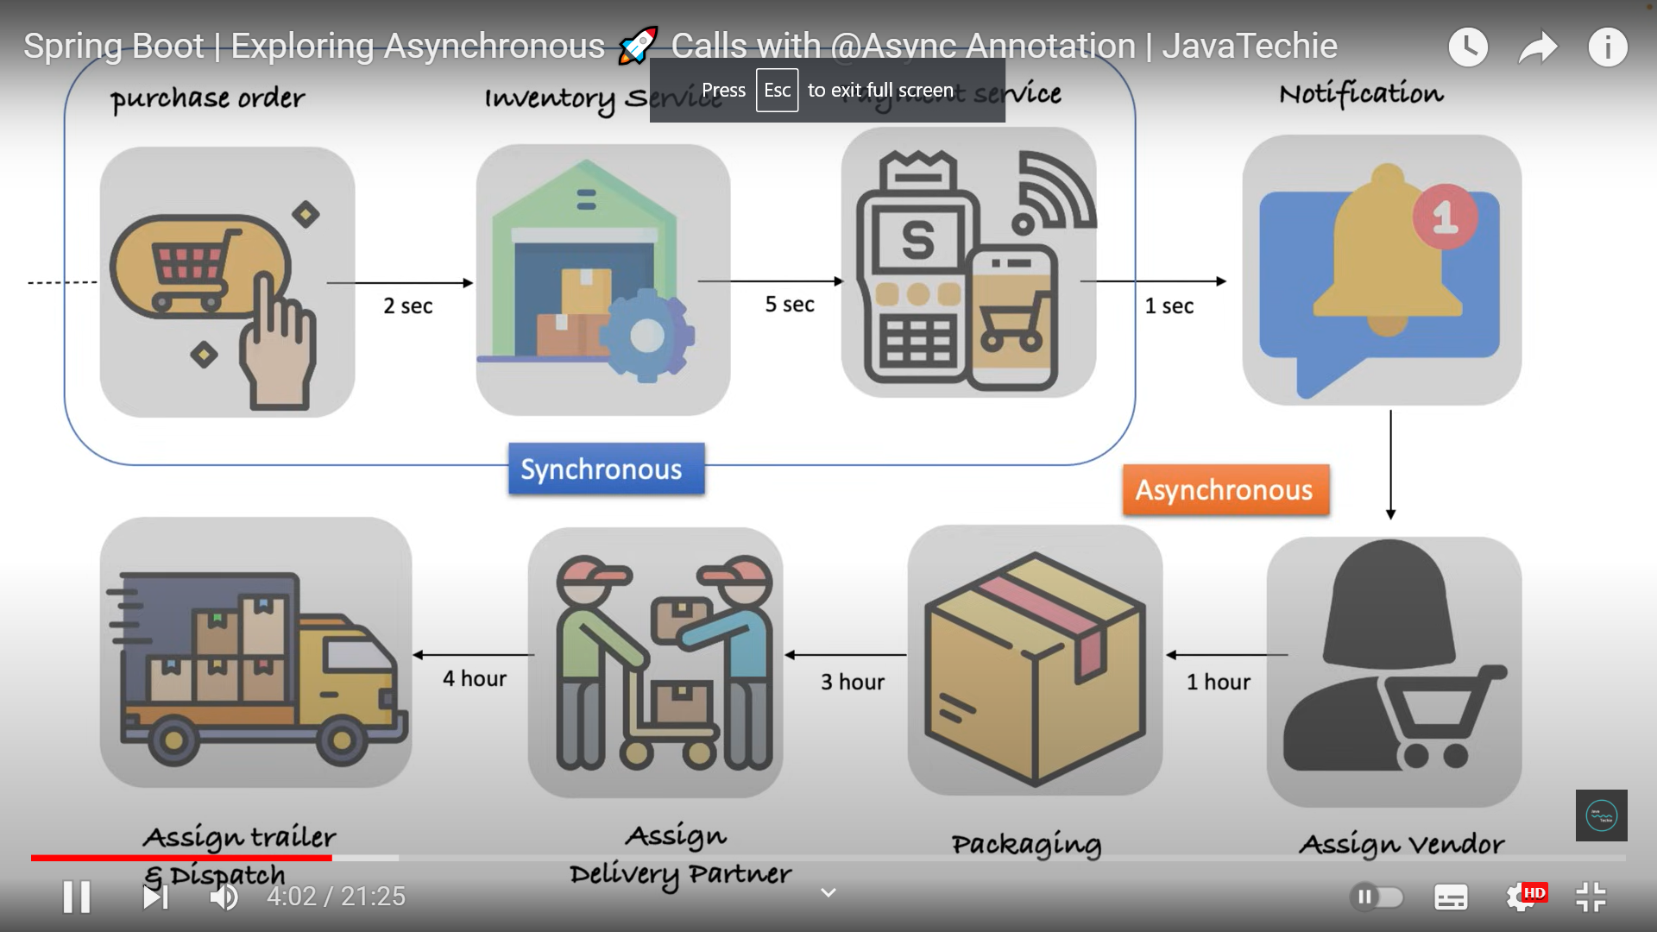

In any e-commerce applications, order fulfillment process has so many services gets involved. In the above diagram, until payment service it is synchronous and then User gets order id and the next steps are asynchronous.

**Synchronous way:**

@PostMapping  
public ResponseEntity<Order> processOrder(@RequestBody Order order) throws InterruptedException {  
 service.processOrder(order); *// synchronous  
 // asynchronous* service.notifyUser(order);  
 service.assignVendor(order);  
 service.packaging(order);  
 service.assignDeliveryPartner(order);  
 service.assignTrailerAndDispatch(order);  
 return ResponseEntity.*ok*(order);  
}

In this logic, if user sends one order request, then this method will not respond until and unless all the above methods are executed which takes so much time and the user does not need to wait until it gets assigned to third-party vendor for delivery or deciding delivery strategy. The user has to get a notification with an order ID once the payment goes through. Next steps like assigning to vendor and deciding other factors must be done in the background which is an asynchronous process. And if we do it synchronously only one thread will execute all these steps and there is no parallel programming. So, for that only we will make a few services synchronous and a few services asynchronous using the @async method.

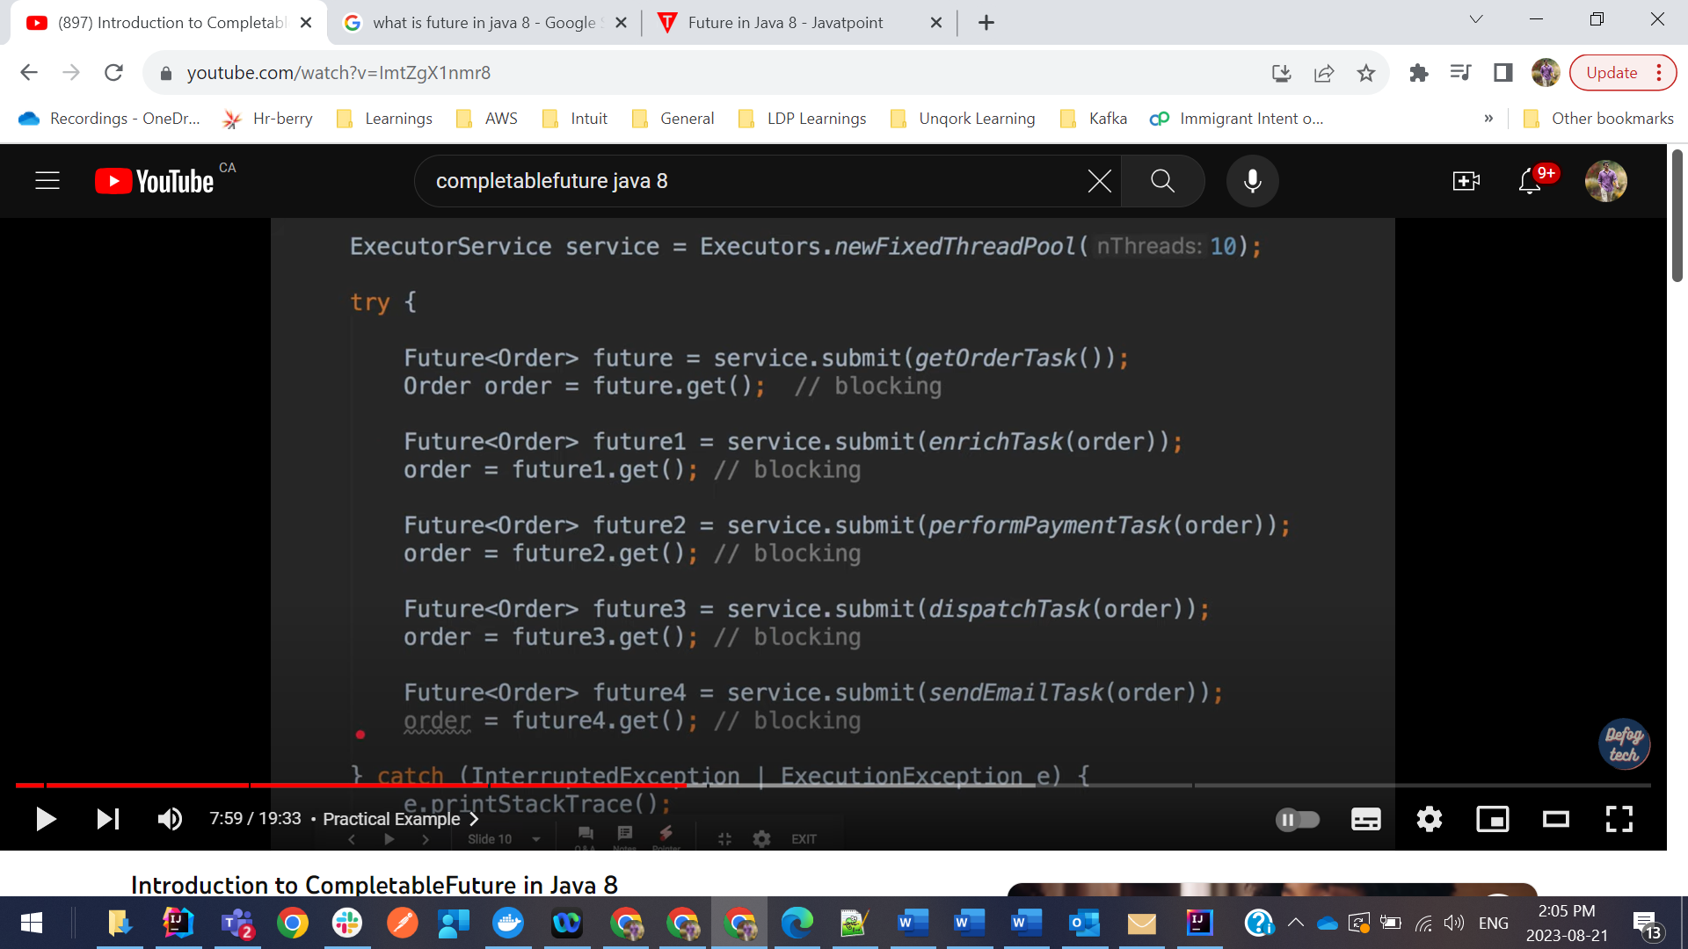

The above picture is blocking operation for multiple orders. Until first order is complete other orders wont be completed this is where we need independent flows

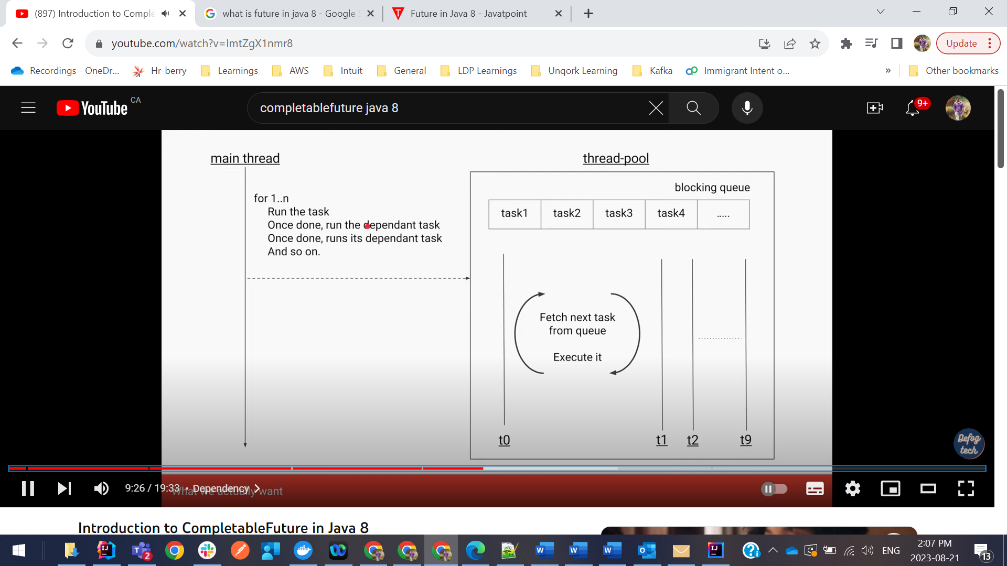

This is where exactly Completable Future comes. So using this, each order will be completed independently and also it wont block main thread.

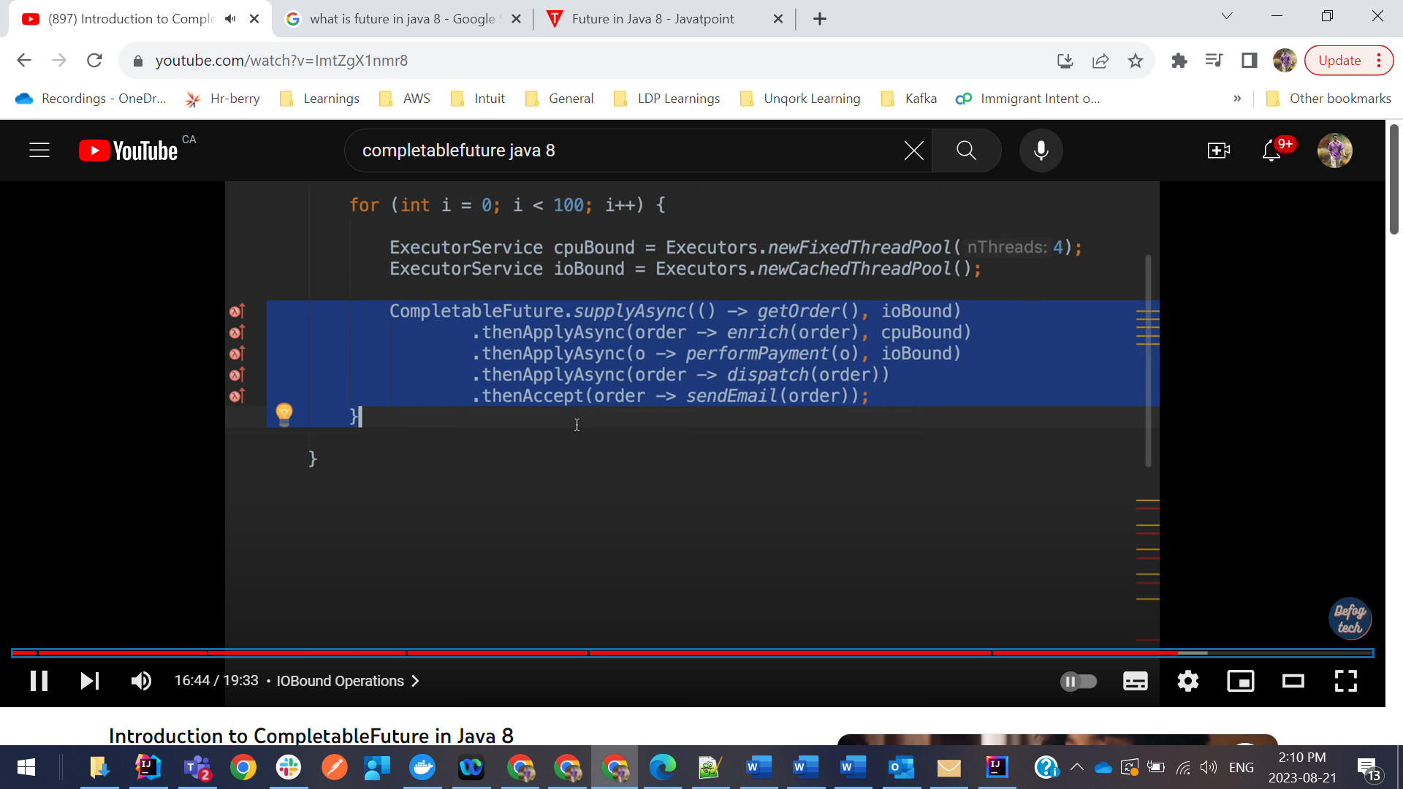

Spring boot Completable Future example:

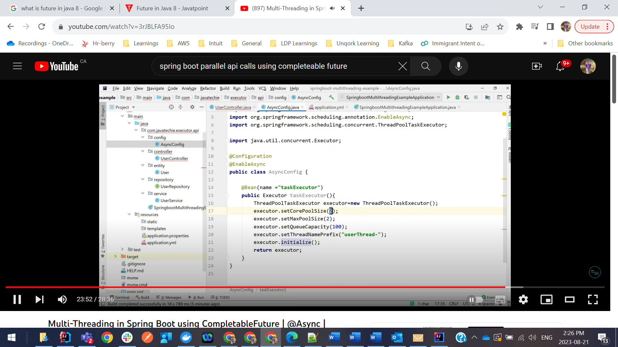

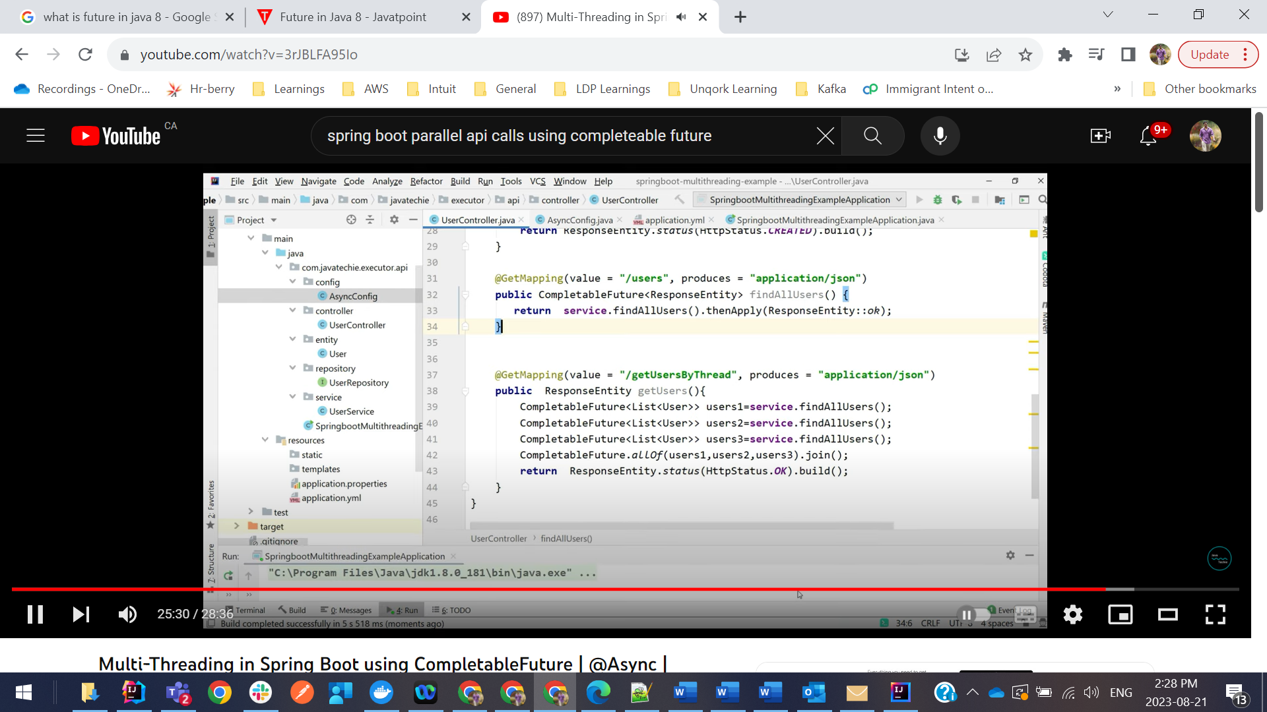

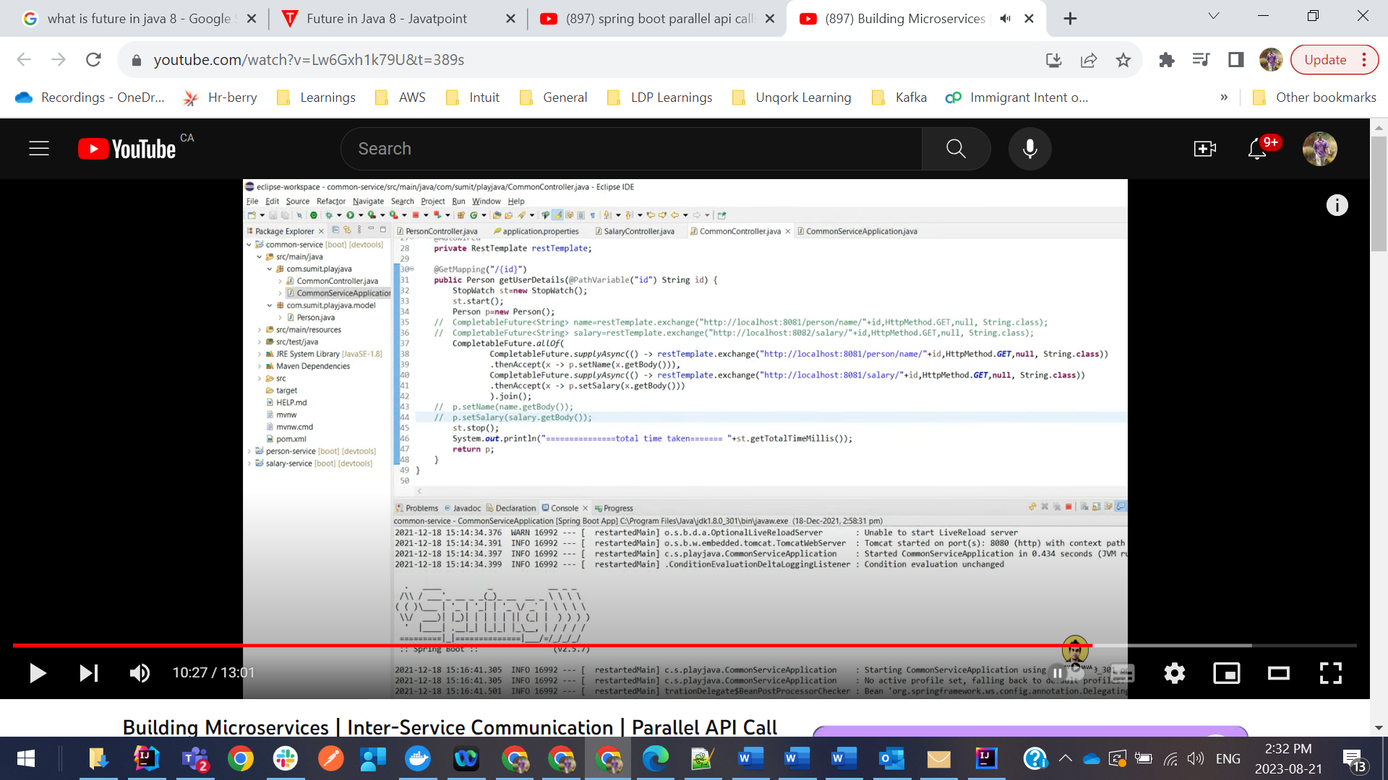

Interview Questions: Still using CompletableFuture in Spring boot is problematic why because

CompletableFuture.allOf(parallelCall1, parallelCall2).join() – Here join() is the problem and it is still blocking why because until and unless the response comes and we join the two responses together and return this object, **main thread is blocked** and are waiting for the response to come.

**Here comes the new paradigm called Reactive Programming:**

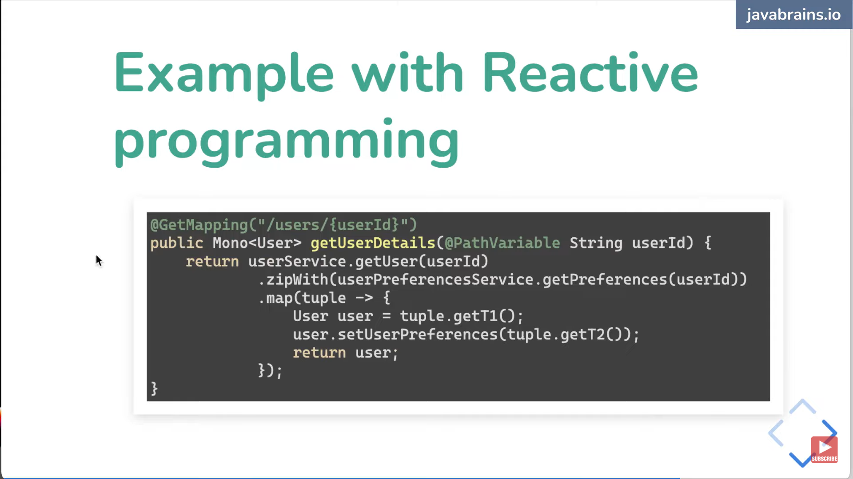

WebClient:

It's important to note that even though it is, in fact, a non-blocking client and it belongs to the spring-webflux library, the solution offers support for both synchronous and asynchronous operations, making it suitable also for applications running on a Servlet Stack.

Account accountResponse = client.get()  
 .uri(Constants.studentAccountAPIUrl)  
 .retrieve()  
 .bodyToMono(Account.class)

In the above example, we called .retrieve() to get a ResponseSpec for a request. This is an asynchronous operation, which doesn’t block or wait for the request itself, which means that on the following line the request is still pending, and so we can’t yet access any of the response details.

### Flux

A Flux represents a stream of elements. It’s a sequence that will asynchronously emit any number of items (0 or more) in the future, before completing (either successfully or with an error).

In reactive programming, this is our bread-and-butter. A Flux is a stream that we can transform (giving us a new stream of transformed events), buffer into a List, reduce down to a single value, concatenate and merge with other Fluxes, or block on to wait for a value.

### Mono

A Mono is a specific but very common type of Flux: a Flux that will asynchronously emit either 0 or 1 results before it completes.

<https://reflectoring.io/spring-webclient>

* With Reactive programming we are going away from Thread per Request Model.

<https://www.youtube.com/watch?v=IGekSCoJav0&list=PLnXn1AViWyL70R5GuXt_nIDZytYBnvBdd&index=2>

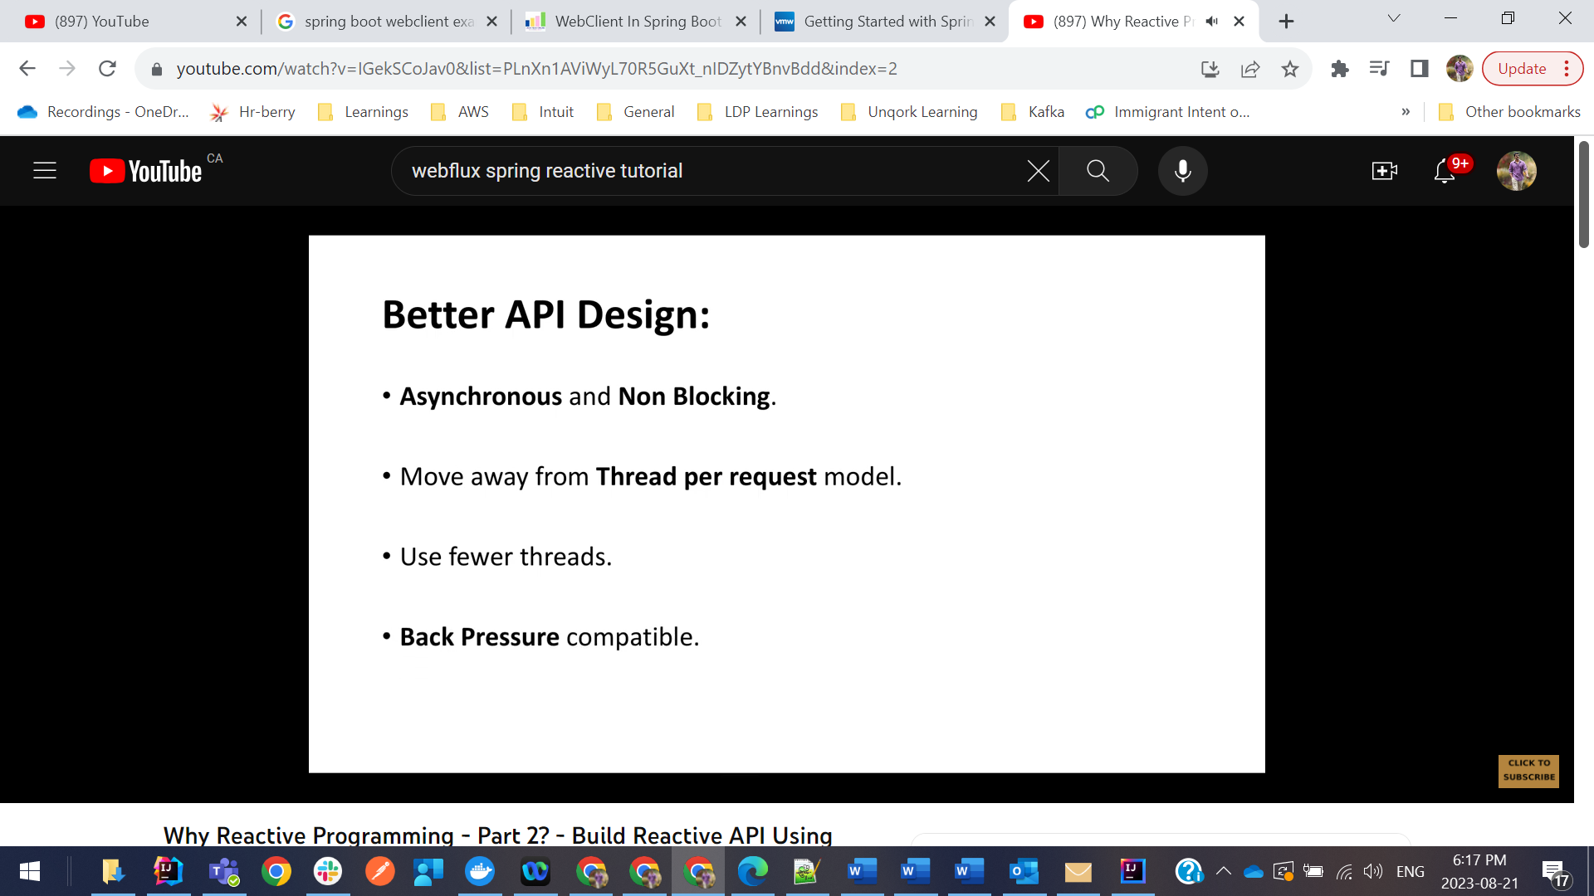

Important: In traditional API design, once the request comes, a thread is assigned to that request. Now lets say that request need to call 4 other API’s to get information but we have only one thread for that request and thread will start first API call and it will wait for the response and then once response comes and next API call will be triggered so here operation is blocked until first API response comes. This way API performance will be impacted.

* Reactor-core:
* Flux – represents 0 to n elements
* Mono – represents 0 to 1 element. Mono can return on List object.
* We need to use Flux for more than one element and Mono is just for one element.

// Continue from here for real time project using WebFlux

<https://www.youtube.com/watch?v=ZpgXAn3HBZk&list=PLnXn1AViWyL70R5GuXt_nIDZytYBnvBdd&index=8>

Sort,Duplicates suggestions:

* 1. To remove duplicates from a list of integers just use list.stream().distinct()
  2. To remove duplicates from a list of custom objects then override hashcode and equals methods in custom object and then list.stream().distinct()
  3. If we put duplicate records in Map, it will override previous value. So we need to override hashcode and equals() method properly.

**Spring Reactive Programming:**

WebFlux is already non-blocking which means that your application will be capable of handling other requests / processes while waiting for the Database to return the results of your query. Spring webflux is built with the idea of reactive and non-blocking programming. It is built to leverage the time which goes into waiting for I/O calls to complete. CompletableFuture is built as an advancement to Future interface. Both of these are used for asynchronous programming in java.

Flux: A Flux Publisher in Reactor publishes data or event and can produce from 0 to N values asynchronously.

Mono: There is only one value that a Mono publisher can produce, or perhaps none at all.

o get more control, we’ll set an explicit duration:

**String** result = blockingHelloWorld().block(Duration.of(1000, ChronoUnit.MILLIS));

assertEquals(expected, result);Copy

If the publisher doesn’t emit a value within the set duration, a RuntimeException is thrown.

Additionally, Mono could be empty and the block() method above would return null. In that case, we could make use of blockOptional:

Optional<String> result = Mono.<String>empty().blockOptional();

assertEquals(Optional.empty(), result);

return webClient.post()  
 .header(HttpHeaders.*AUTHORIZATION*, *BEARER* + token)  
 .contentType(MediaType.*MULTIPART\_FORM\_DATA*)  
 .body(BodyInserters.*fromMultipartData*(multipartData))  
 .retrieve()  
 .onStatus(resp -> resp.is4xxClientError() || resp.is5xxServerError(),  
 resp -> onErrorStatus(resp, openAiTokenProperties.getTranscriptionUrl()))  
 .toEntity(TranscriptionTask.class)  
 .retryWhen(Retry.*max*(*MAX\_ATTEMPTS*)  
 .filter(throwable -> {  
 return throwable instanceof SpeechConversionException;  
 })  
 .onRetryExhaustedThrow(((retryBackoffSpec, retrySignal) -> {  
 *log*.error("After 3 attempts OpenAi problem on URL: {}", openAiTokenProperties.getTranscriptionUrl());  
 throw new SpeechConversionException(*TRY\_AGAIN\_MESSAGE*);  
 })  
 ))  
 .blockOptional()  
 .orElseThrow(() -> new SpeechConversionException(*TRY\_AGAIN\_MESSAGE*));

### Non-Blocking Request

In a non-blocking system, all the incoming requests are accompanied by an event handler and a callback. The request thread delegates the incoming request to a thread pool that manages a pretty small number of threads. Then the thread pool delegates the request to its handler function and gets available to process the next incoming requests from the request thread.

When the handler function completes its process, one of the threads from the pool fetches the response and passes it to the callback function. Thus the threads in a non-blocking system never go into the waiting state. This increases the productivity and the performance of the application.

A single request is potentially processed by multiple threads!

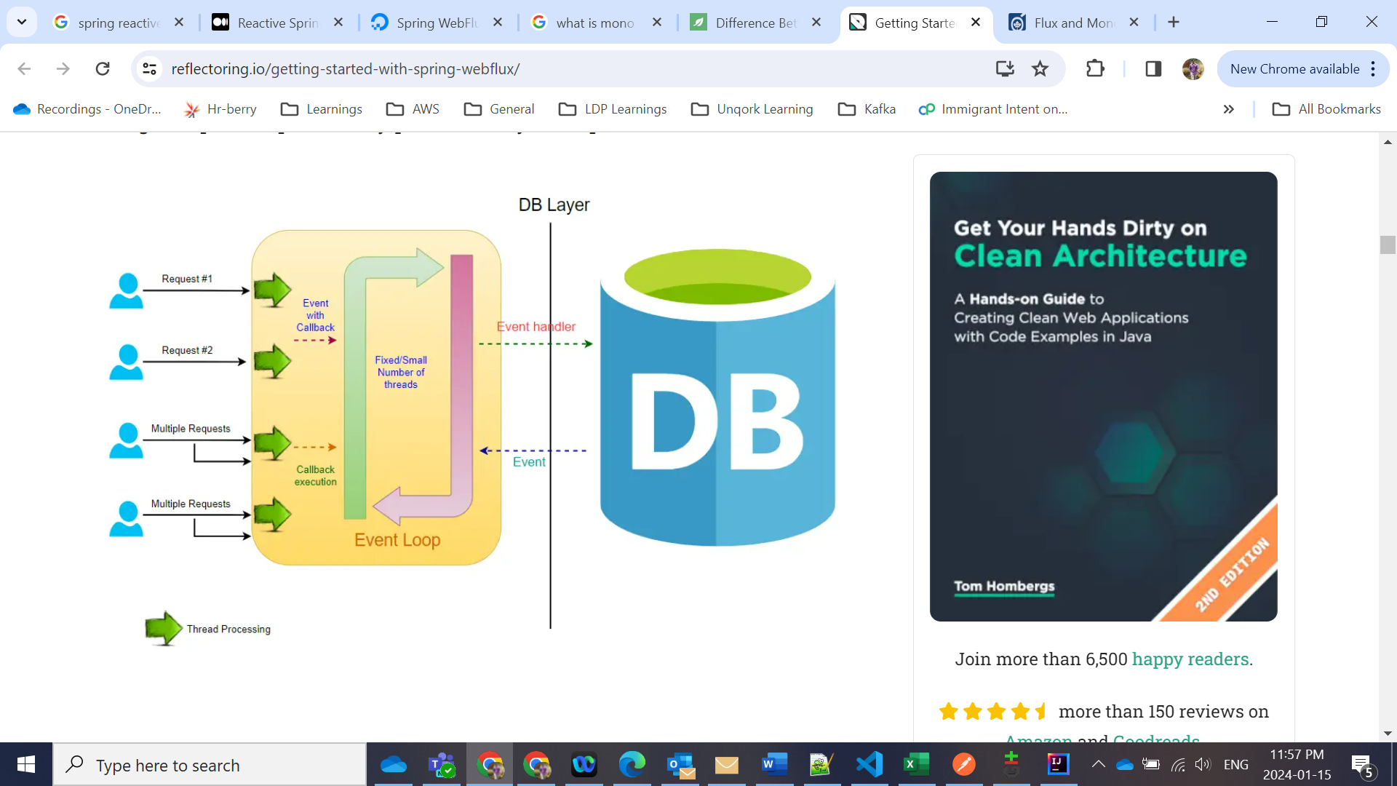

Reactor also provides operators to work with Mono and Flux objects. Some of them are:

* Map - It is used to transform from one element to another.
* FlatMap - It flattens a list of Publishers to the values that these publishers emit. The transformation is asynchronous.
* FlatMapMany - This is a Mono operator which is used to transform a Mono object into a Flux object.
* DelayElements - It delays the publishing of each element by a defined duration.
* Concat - It is used to combine the elements emitted by a Publisher by keeping the sequence of the publishers intact.
* Merge - It is used to combine the publishers without keeping its sequence.
* Zip - It is used to combine two or more publishers by waiting on all the sources to emit one element and combining these elements into an output value.

**Understanding Backpressure in Reactive Programming**

In Reactive programming, backpressure is a mechanism that allows the consumer of data to control the rate at which the producer produces data. This is important because, in many scenarios, the producer may be generating data faster than the consumer can process it, leading to a buildup of unprocessed data, which can cause memory and performance issues.

Backpressure enables the consumer to signal the producer to slow down or stop producing data until the consumer is ready to accept more. This can be implemented using various techniques such as buffering, dropping data, or requesting the producer to slow down.

For example, in a stream processing application, if the producer is generating data at a high rate, the consumer may not be able to keep up with the rate of data consumption. To avoid data overload, the consumer can signal the producer to slow down by applying back pressure. The producer will then pause or slow down until the consumer is ready to accept more data.

Backpressure ensures that both producers and consumers can operate at their optimal processing rates without causing any bottlenecks or overloading the system.

@GetMapping(produces = MediaType.TEXT\_EVENT\_STREAM\_VALUE)  
public Flux<UserResponse> retrieveUsers() {  
 return userService.retrieveUsers()  
 .onBackpressureBuffer(10, BufferOverflowStrategy.DROP\_OLDEST)  
 .delayElements(Duration.ofMillis(100))  
 .log();  
}

**Important:** To implement backpressure we extend base class called BaseSubscriber and then override hookOnNext() method.

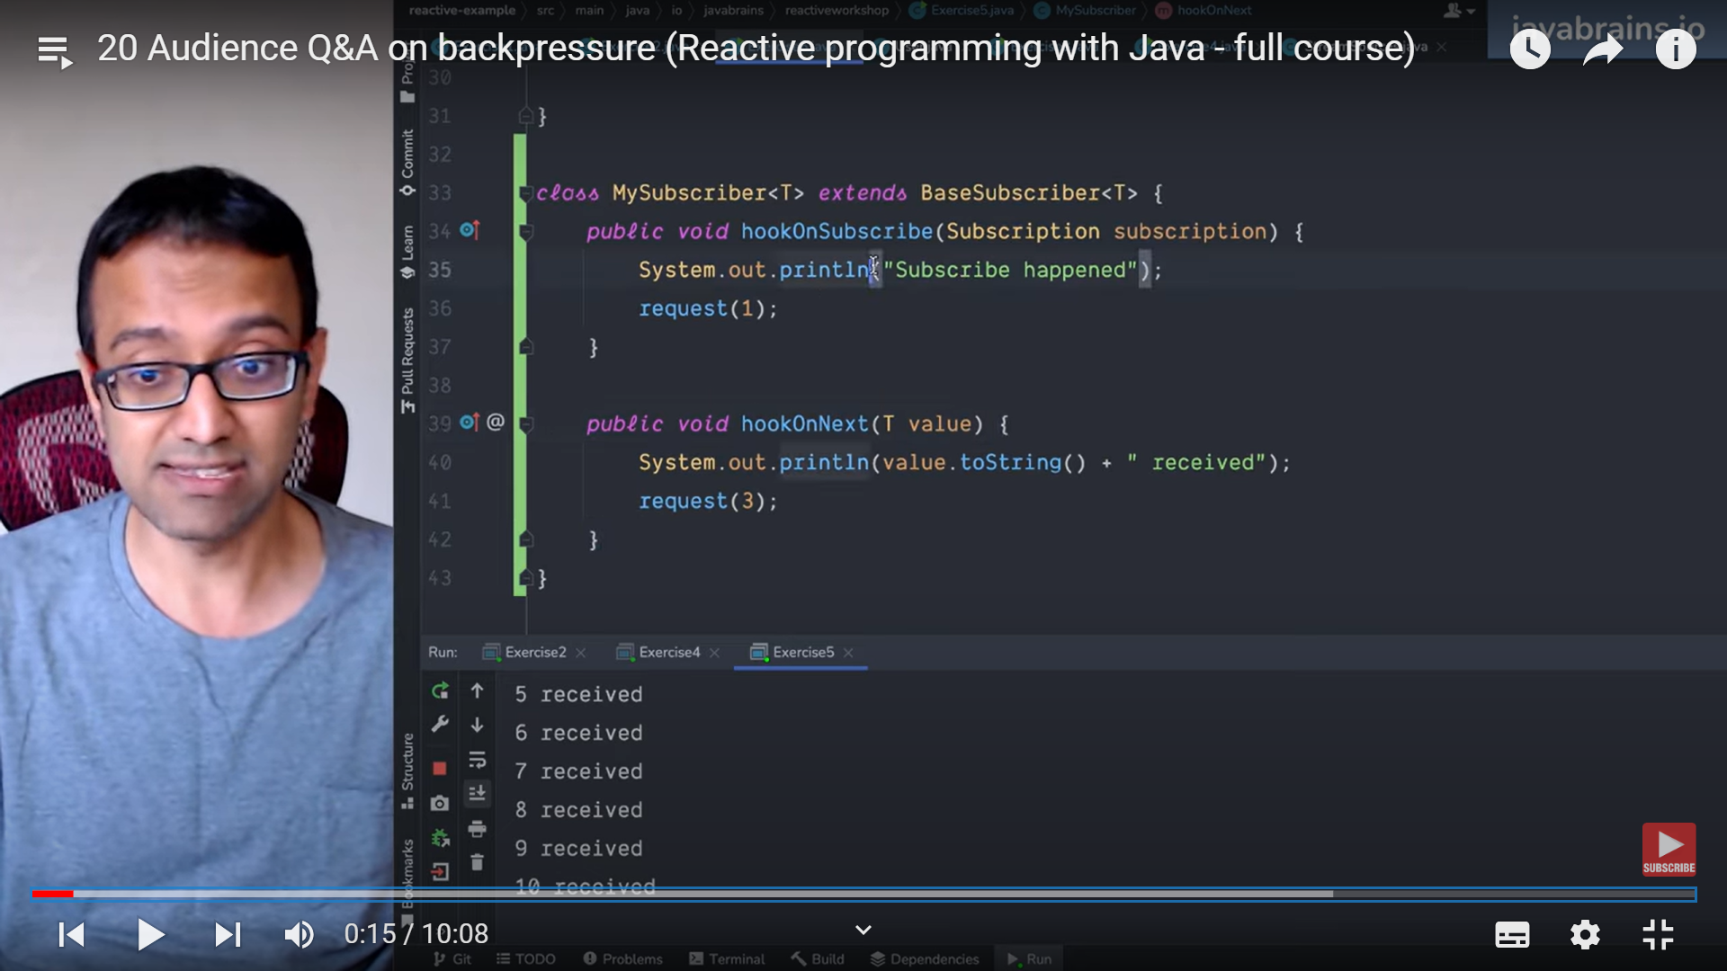

**Example:**

Imagine going into a Café and ordering your favorite caffeinated beverage. After placing the order, you could wait around, maybe have a look at the busy street outside, until the barista finished your coffee. Or, right after ordering, you could pick up your phone, answer an email and check up on your next meeting, all the while being ready to *react* to the barista calling your name. As I said, it is easy to grasp the concept and understand, which one can be more efficient if implemented correctly, but it is not so easy to understand, how this is achieved behind the facade of a framework, such as [Spring](https://docs.spring.io/spring-framework/docs/current/reference/html/web-reactive.html).

Important**: In the above example, here the person is thread, once thread completes ordering the food, it can serve other requests**

* Flux acts as source in the observer pattern means it’s the publisher. Flux is like data available over time but Stream is like data is like whatever available now (one time arrival of data).
* toStream() method in Flux takes data from the flux and converts to Stream.
* If we are using .block() method then it is simply blocking operation.
* The subscriber might receive following from the source/publisher:
  1. An item
  2. The completion event from source – **Terminal event**
  3. A failure event – **Terminal event**

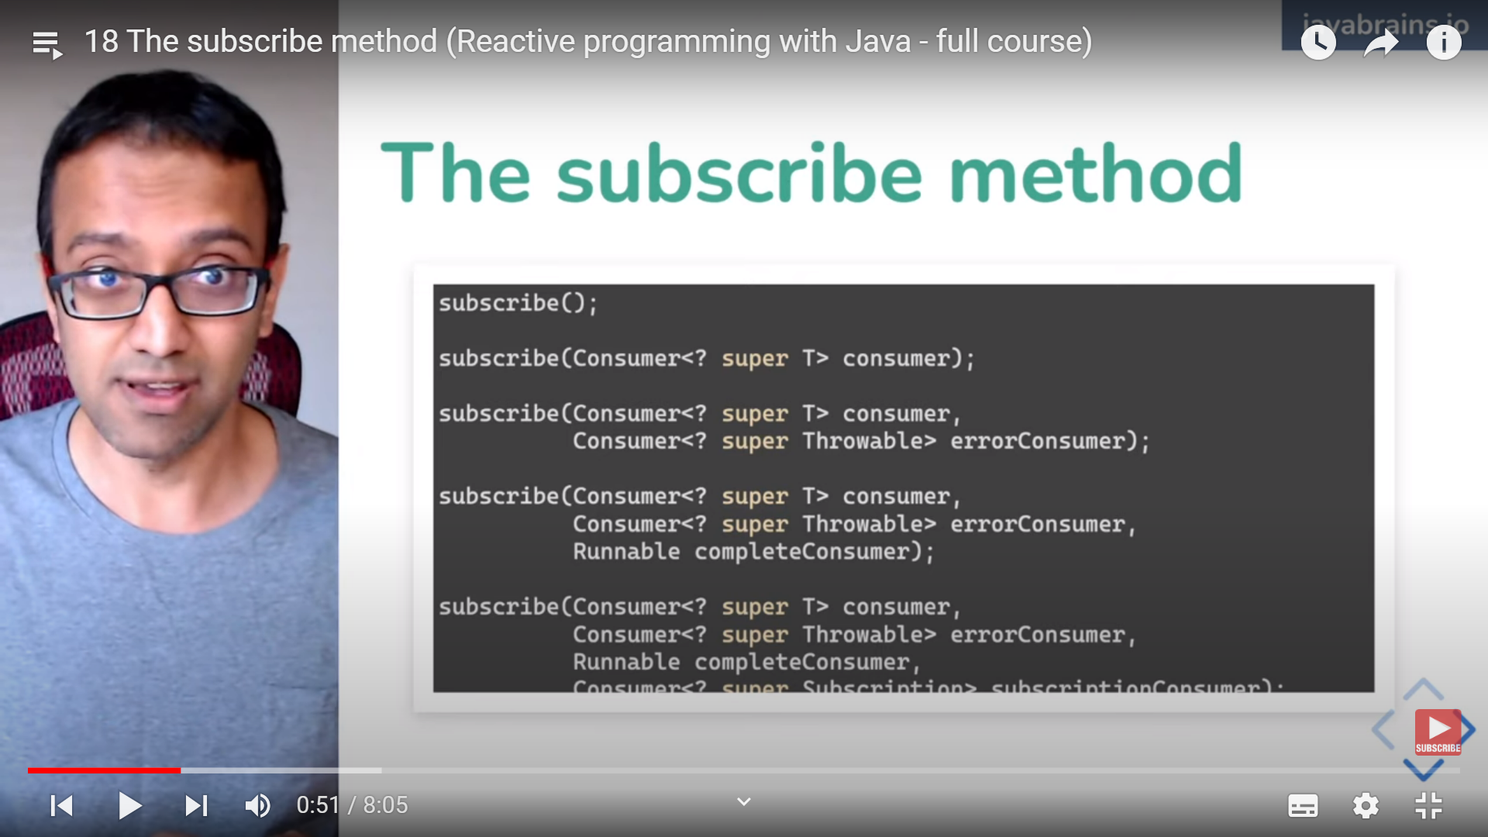

* **Important:** Using subsribe method, consumer subscribes to the publisher and receive the item using Flux/Mono and then assign an observer(which is the functionality gets executed) to the publisher so we are saying to the publisher, hey if there is any new value comes then execute this functionality which is called side effect.
* If you want to end any subscription then: What you get when you subscribe is Disposablewhich you can dispose using subscription.dispose() method.
* For unresponsive Mono/Flux then in block() method add Timeout.
* Why block() and whats the point? : Even we are using block() we are making it reactive and also handling requests in a reactive way like threads does not need to hang around to get the result. Netty is again the reactive web servers. Now the requests are blocked at Framework level and not at each and every step. This way number of thread blocked are reduced significantly.

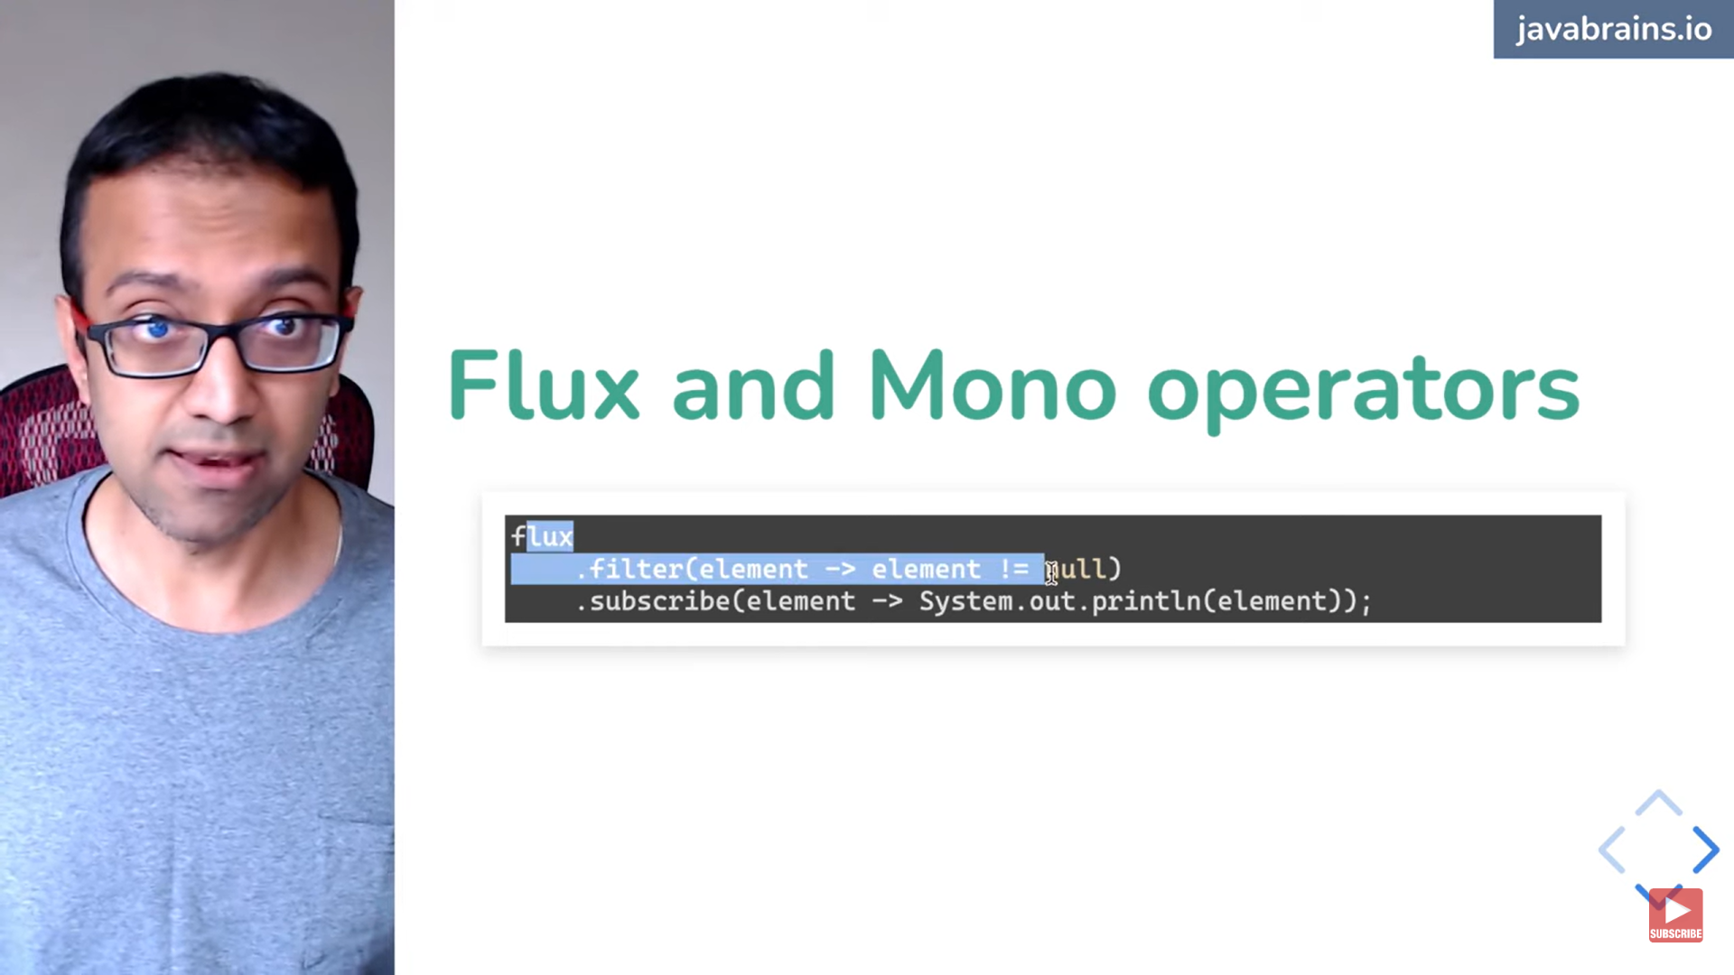

* **In reactive programming controller should send data as Stream**

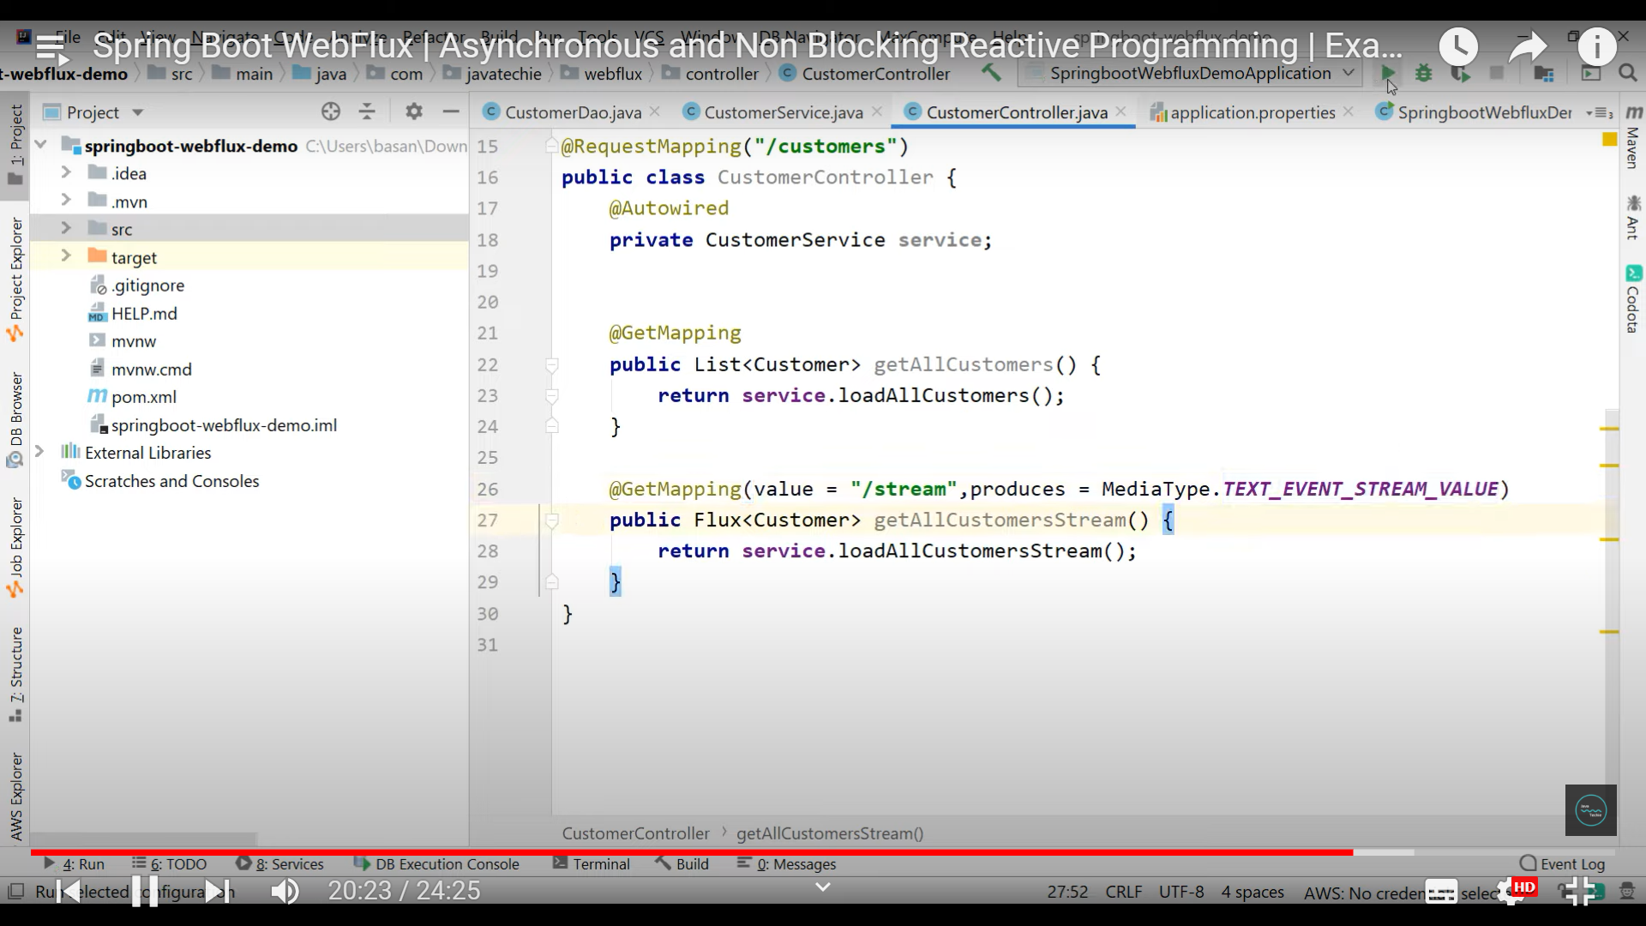

**Server Side Events for Continuous data: Important**

package com.example.demo;

import com.fasterxml.jackson.core.JsonProcessingException;

import com.fasterxml.jackson.databind.ObjectMapper;

import org.springframework.http.MediaType;

import org.springframework.web.bind.annotation.CrossOrigin;

import org.springframework.web.bind.annotation.GetMapping;

import org.springframework.web.bind.annotation.RestController;

import reactor.core.publisher.Flux;

@RestController

public class ServerSentEventController {

private final Flux<ProfileCreatedEvent> events;

private final ObjectMapper objectMapper;

public ServerSentEventController(ProfileCreatedEventPublisher eventPublisher, ObjectMapper objectMapper) {

this.events = Flux.create(eventPublisher).share();

this.objectMapper = objectMapper;

}

@GetMapping(path = "/sse/profiles", produces = MediaType.TEXT\_EVENT\_STREAM\_VALUE)

@CrossOrigin(origins = "http://localhost:3000")

public Flux<String> profiles() {

return this.events.map(pce -> {

try {

return objectMapper.writeValueAsString(pce) + "\n\n";

} catch (JsonProcessingException e) {

throw new RuntimeException(e);

}

});

}

}

**https://medium.com/simform-engineering/deep-dive-into-reactive-programming-with-spring-boot-d62cae63bb03**

**Reactive Streams introduced in Java 9:**

Resiliency4j:

* Retry
* retryWhen(Retry.*max*(*MAX\_ATTEMPTS*)  
   .filter(throwable -> {  
   return throwable instanceof SpeechConversionException;  
   })  
   .onRetryExhaustedThrow(((retryBackoffSpec, retrySignal) -> {  
   *log*.error("After 3 attempts OpenAi problem on URL: {}", openAiTokenProperties.getTranscriptionUrl());  
   throw new SpeechConversionException(*TRY\_AGAIN\_MESSAGE*);  
   })  
   ))
* RateLimitter

**Collections Framework:**

Question? Fibonacci series using normal and recursive?

1. If you want to sort the list of type String then just use Collections.sort(listCollection)

**List Interface:**

ArrayList : 1) Maintains insertion order

2)allows duplicate elements.

3) Dynamic array is used inside ArrayList means index based.

4) The size of an ArrayList is increased automatically if the collection grows or shrinks if the objects are removed from the collection

5) In Java ArrayList class, manipulation is slow because a lot of shifting needs to have occurred if any element is removed from the array list.

* **CopyOnWriteArrayList:** This class implements the list interface. It is an enhanced version of [ArrayList](https://www.geeksforgeeks.org/arraylist-in-java/) in which all the modifications(add, set, remove, etc.) are implemented by making a fresh copy of the list.
* If we use CopyOnWriteArrayList then we can add and remove from the original list itself like list.remove() and list.add() and these are called fail-safe iterators.
* CopyOnWriteArrayList is a thread-safe variant of the ArrayList in which all mutative operations (add, set, etc.) are implemented by making a new copy of the underlying array. It belongs to the *java.util.concurrent* package and is designed for scenarios where iteration far more frequently happens than modification.

Linked List: 1) Maintains insertion order

1. Internally it implements LinkedList Data Structure which is linear data structure. Means Nodes where each node is connected to next node.

Important: Iterator vs ListIterator:

In iterator, you cannot remove from the original list but you have remove() method in iterator so you can do iterator.remove() based on condition.

Important: Whether you are using iterator or listiterator, for normal collection like ArrayList, if you use list.remove() then we get ConcurrentModificationException so you have to use iterator.remove() method.

But we can use list.remove() in CopyOnWriteArrayList method.

**List.remove()** and **Iterator.remove()** are two different methods for removing elements from a list, and their behavior can differ, especially in the context of a **CopyOnWriteArrayList**. Let's discuss the differences:

1. **List.remove() in CopyOnWriteArrayList:**
   * The **List.remove()** method removes the specified element from the list.
   * In the case of a **CopyOnWriteArrayList**, the **remove(Object o)** method is supported, but it may result in a new copy of the underlying array being created, which can be inefficient for large lists.
   * Since **CopyOnWriteArrayList** is designed for situations where reads significantly outnumber writes, using **remove(Object o)** frequently might not be the most efficient choice.

Example:

javaCopy code

CopyOnWriteArrayList<String> copyOnWriteList = new CopyOnWriteArrayList<>(); copyOnWriteList.add("Java"); copyOnWriteList.add("Python"); copyOnWriteList.remove("Java"); // Removes "Java" from the list

1. **Iterator.remove() in CopyOnWriteArrayList:**
   * The **Iterator.remove()** method removes the last element that was returned by the iterator.
   * In the context of a **CopyOnWriteArrayList**, using **Iterator.remove()** is generally more efficient than **List.remove()** for removing elements during iteration. This is because **Iterator.remove()** doesn't need to create a new copy of the underlying array.

Example:

javaCopy code

CopyOnWriteArrayList<String> copyOnWriteList = new CopyOnWriteArrayList<>(); copyOnWriteList.add("Java"); copyOnWriteList.add("Python"); Iterator<String> iterator = copyOnWriteList.iterator(); while (iterator.hasNext()) { String element = iterator.next(); if (element.equals("Java")) { iterator.remove(); // Removes "Java" from the list efficiently } }

In summary, when working with a **CopyOnWriteArrayList**, using **Iterator.remove()** is generally more efficient than **List.remove()** for removing elements during iteration. It leverages the copy-on-write semantics of the list, avoiding the need to create a new copy of the underlying array.

ArrayList vs LinkedList:

* Use ArrayList when you want to perform more read operations and less insertions or deletions and also more fetch operations.
* ArrayList has less memory overhead compared to LinkedList as LinkedList is based on DoublyLinkedLink and it needs to store the address of previous element also.
* If your application involves mainly read operations and occasional insertions or deletions, **ArrayList** is a good choice.
* **LinkedList** excels in scenarios where there are frequent insertions or deletions in the middle of the list. Insertion and deletion operations are faster (O(1)) as they only involve updating the adjacent nodes' references.
* If your application involves frequent sequential iteration of the entire list, **LinkedList** can be efficient due to its sequential access nature.

Set Interface:

* Set will not have duplicate elements. HashSet allows one null key.
* Set does not maintain insertion order. If you want insertion order, we have LinkedHashSet
* TreeSet will by default sort the set in ascending order.
* LinkedHashSet allows one null key but TreeSet does not allow null key as it is used for sorting.
* No Position access or index access, Set interface doesn't provide any methods to access the element by an index as Set doesn't maintain any fixed order.
* HashSet internal implementation 🡪 HashMap
* TreeSet internal implementation 🡪 TreeMap

HashSet:

HashSet is implemented in terms of a hash table. It uses a mechanism called hashing to store the elements. HashSet internally uses HashMap to store the elements.

The add, remove, and contains methods have constant time complexity O(1). It offers constant-time performance for the basic operations (add, remove, contains, and size).

The initial default capacity of HashSet is 16, and the default load factor is 0.75.

In Java, the HashSet class does not have a *get()* method to access its elements as it is not an indexed collection. The order of elements in a HashSet is not guaranteed, hence, we cannot directly access an element of the HashSet.

Set<String> synchronizedSet = Collections.synchronizedSet(set);

TreeSet:

TreeSet stores elements in a sorted manner

TreeSet cannot contain **duplicate** elements.

TreeSet cannot contain a **null** value.

TreeSet operations like add, remove, and contains methods take O(log(n)) time.

TreeSet internally uses a **[TreeMap](https://www.javaguides.net/2018/07/guide-to-treemap-class.html" \t "_blank)** to store elements.

* [**TreeSet**](https://www.javaguides.net/2018/07/guide-to-treeset-class.html) does not consider initial capacity or load factor since it is tree-based.

LinkedHashSet:

LinkedHashSet is a HashSet with a linked list implementation that maintains insertion order. So, when you iterate through elements in a LinkedHashSet, they will be returned in the order in which they were inserted.

LinkedHashSet allows one null element.

It is useful when you want to maintain the order of elements (based on insertion order) but also want to avoid duplicates.

**LinkedHashSet:** The performance is slightly on the slower side as it also maintains LinkedList internally to maintain the insertion order of elements. [**LinkedHashSet**](https://www.javaguides.net/2018/06/guide-to-linkedhashset-class.html) uses a hybrid of a hash table and a linked list

**CopyOnWriteArraySet**: While the data can be iterated safely across multiple threads, the copy-on-write nature can be expensive for frequent modifications. It's most suitable for cases where iterations vastly outnumber modifications.

### Why is only one null key allowed in HashSet?

As there is no null check in the add method, so one null key is allowed. However, it can’t be duplicated.

### What is a LinkedHashSet?

It is a subclass of the HashSet class that implements the set interface. It maintains a doubly-linked list across it all elements and is a well-ordered version of HashSet.

**HashMap:**

HashMap uses a technique called Hashing, which allows us to access elements directly by calculating a unique key from their content. This unique key is the index at which the specific value is stored, making retrieval efficient.

HashMap allows one null key and multiple null values in a collection.

The order in which keys or values are inserted into a HashMap is not necessarily the order in which they are iterated.

The keys of HashMap are objects. Hence, these objects must implement the equals method and the hashCode method in order to follow the contract of the Map interface.

**LinkedHashMap:**

Unlike HashMap, the iteration order of the elements in a LinkedHashMap is predictable.

Similar to HashMap, LinkedHashMap allows one null key and multiple null values.

TreeMap:

The TreeMap class in Java is a Red-Black tree-based implementation of the Map interface, which provides a guaranteed log(n) time complexity for the put, get, and remove operations. It stores its elements in a tree and they are automatically arranged in a natural ascending order.

Unlike HashMap and LinkedHashMap, a TreeMap in Java does not allow null keys but it can have null values. If you try to insert a null key, it will throw a NullPointerException.

TreeMap offers a performance of O(log(n)) for most operations like add, remove, and contains tasks.

Java 8 introduced new methods in TreeMap like *newKeySet()*, *descendingKeySet()*, etc. These methods provide more functionality and make it easier to use TreeMap.

WeakHashMap:

**Weak References:**The keys in a WeakHashMap are held weakly, meaning that if the only reference to a key is from the WeakHashMap, it can be garbage collected.

**Use Case:** Ideal for caches where you want entries to be removed once they are no longer referenced elsewhere.

**Nulls:**Both null keys and null values are supported.

# Difference Between HashMap And HashTable In Java

The primary difference between [**HashMap**](https://www.javaguides.net/2018/06/guide-to-hashmap-class.html) and Hashtable is synchronization. *HashTable* is a thread-safe class and can be shared between multiple threads, while HashMap is not thread-safe.

*HashTable* doesn't allow null keys or null values, while [**HashMap**](https://www.javaguides.net/2018/06/guide-to-hashmap-class.html) allows one null key and any number of null values.

**ConcurrentHashMap:**

 The main advantage of *ConcurrentHashMap* over [**HashMap**](https://www.javaguides.net/2018/06/guide-to-hashmap-class.html) is that it allows for simultaneous reads and writes via multiple threads without external synchronization.

Internally, it divides the map into segments. Each segment can be locked independently, allowing high concurrency.

It provides better performance than Hashtable and synchronized HashMap due to the granular locking mechanism.

Unlike [**HashMap**](https://www.javaguides.net/2018/06/guide-to-hashmap-class.html), neither keys nor values can be null. Attempting to insert a null key or value will throw a NullPointerException.

The constructor allows you to specify the concurrency level, which hints at the number of concurrently updating threads the map should accommodate.

Its iterators are designed to be fail-safe, which means they won't throw a *ConcurrentModificationException* if the map is modified while being iterated.

Important: Fail Safe vs Fail Fast: Fail Fast throws ConcurrentModification exception if you try to modify the collection where as Fail safe does not throw any exception.

List vs Set

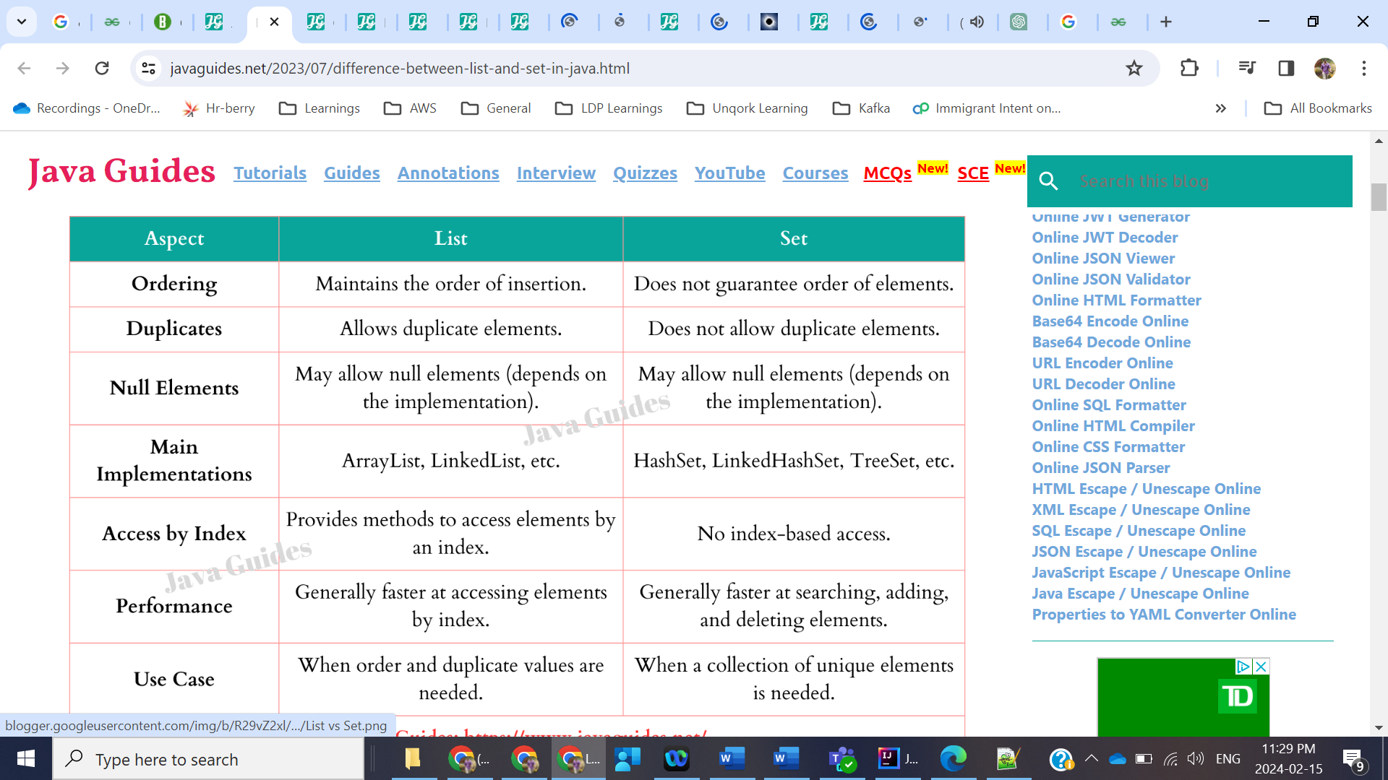

**ArrayList vs LinkedList**

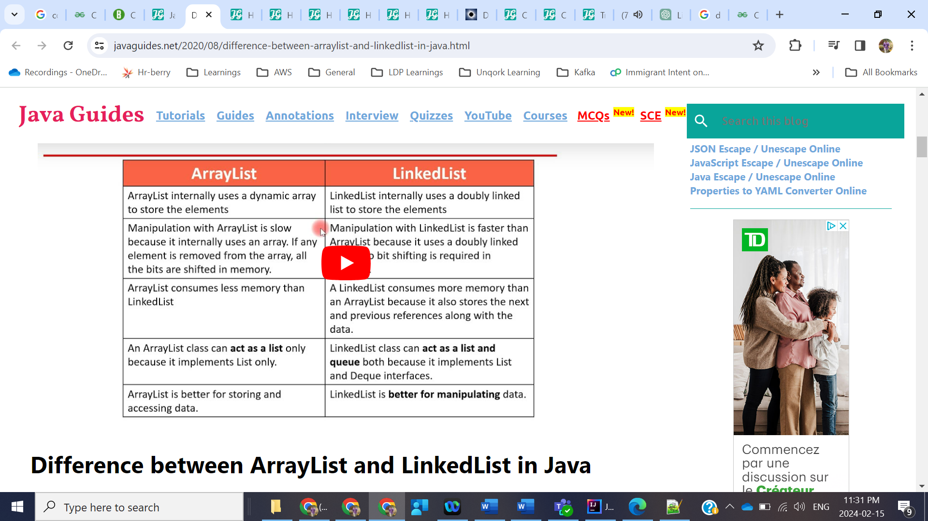

**Collections vs Stream**

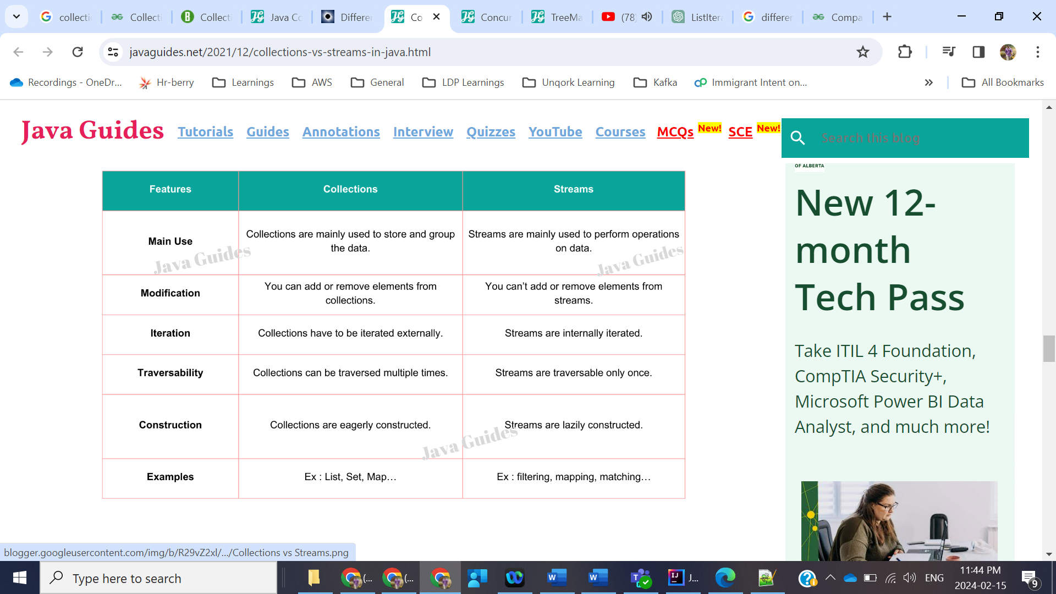

HashMap vs ConcurrentHashMap:

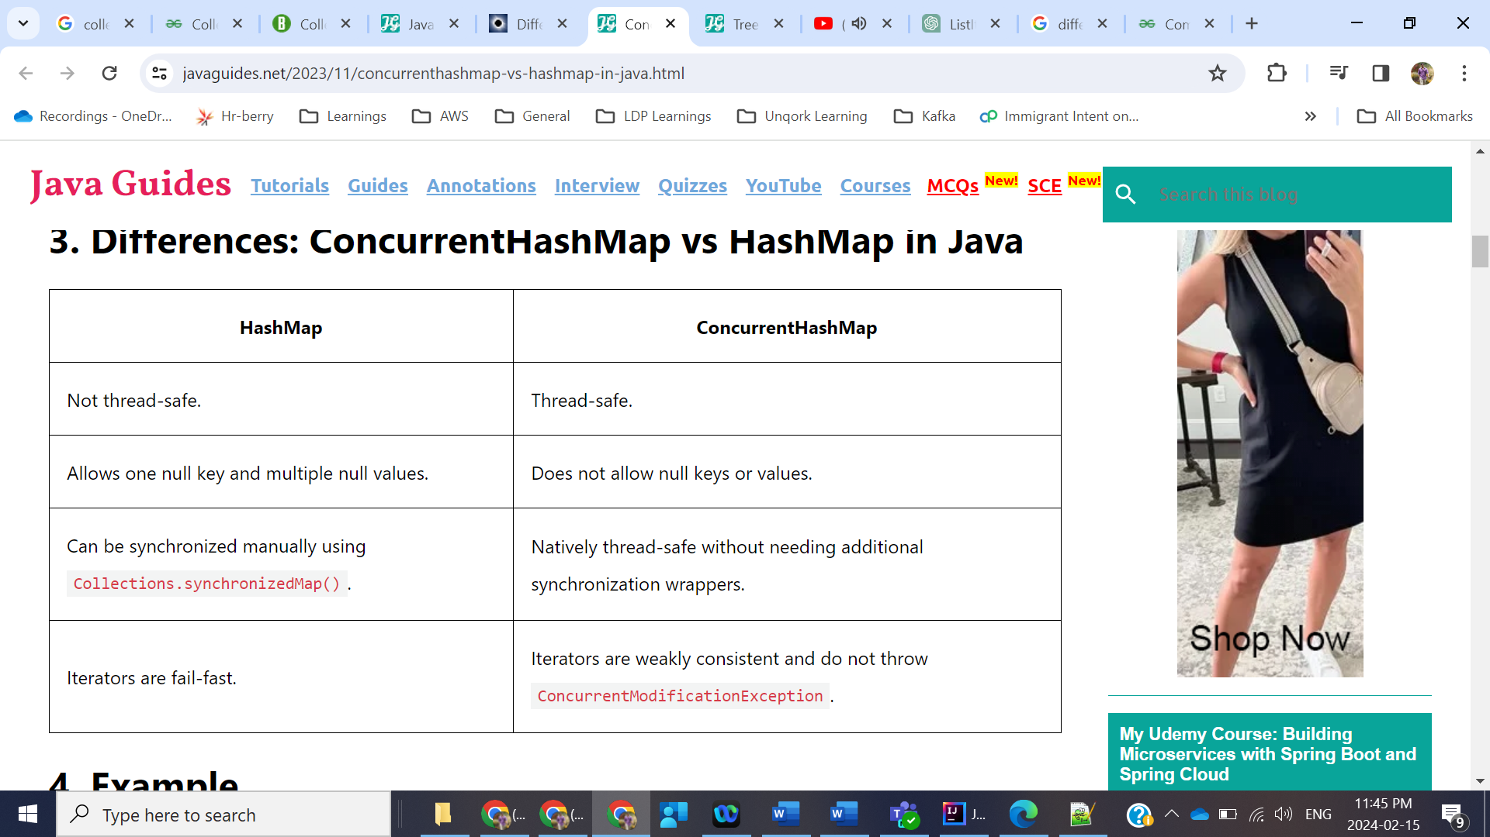

Comparable vs Comparator:

A comparable object is capable of comparing itself with another object. The class itself must implements the **java.lang.Comparable** interface to compare its instances. But the problem with Comparable is that we can sort the collections only based on one category. What if we want to collection based on multiple fields like year, age, salary then we have to use Comparator.

* Comparable is from Java.lang package and is not Functional interface whereas Comparator is from Util package and is Functional interface.

HashMap Implementation:

<https://prateeknima.medium.com/internal-working-of-hashmap-in-java-e5b67890e152#:~:text=To%20improve%20the%20working%20of,(log%20n)%20retrieval%20performance>.

So basically HashMap used Hashtable implementation internally. There is a bucket of arrays and whenever we insert one key, value then hashing will be done on key and it will identify the location in the bucket based on the hashing output. If two keys have same hashcode, then it is called collision that is why each value is store as LinkedList as each key will have reference to the next value that way many keys are stored at one index in bucket.

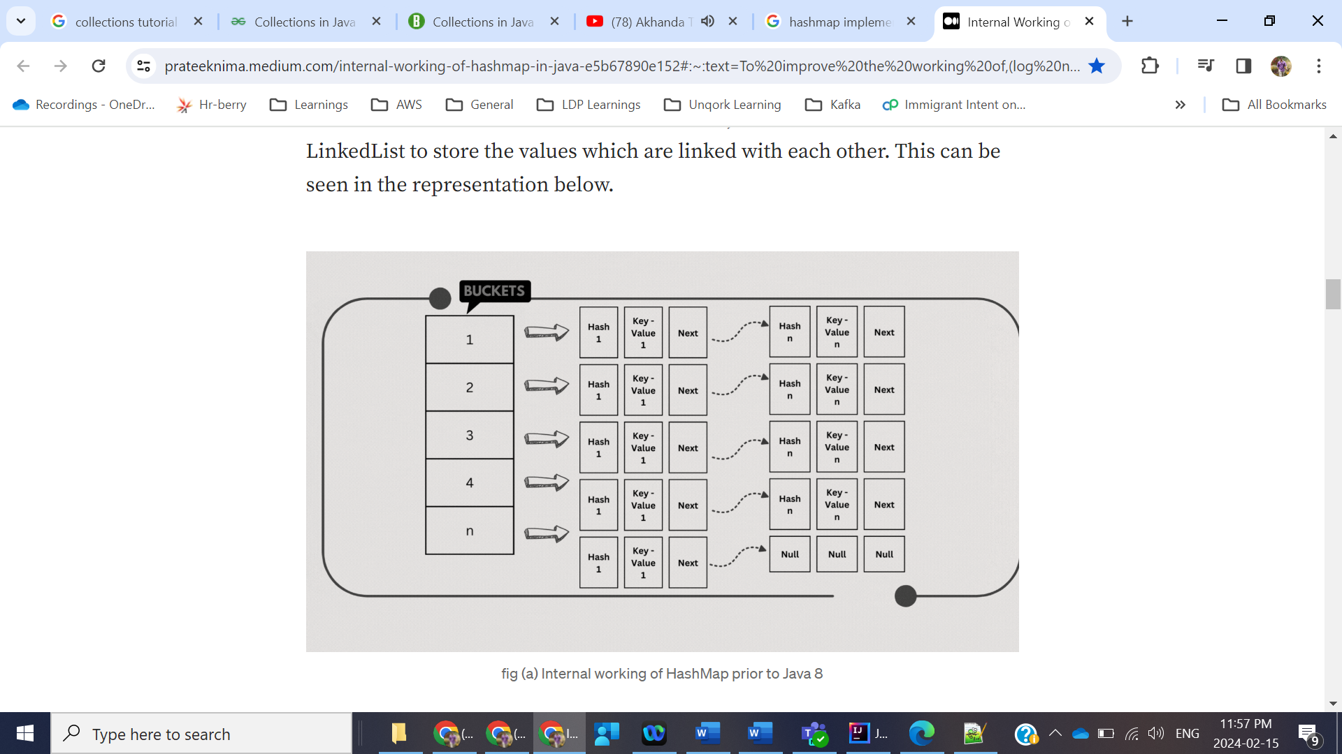

To improve the working of HashMap, Java 8 made updates to the internal implementation workflow. Once a certain threshold level is reached, the values are now automatically stored in a tree manner rather than a linked list. So instead of O(n) retrieval time, we now have better O(log n) retrieval performance.

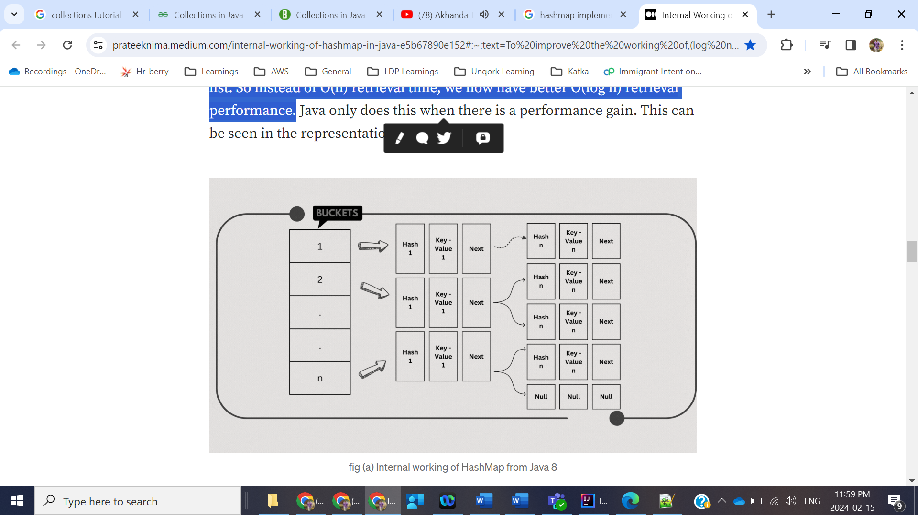

**TreeNodes** are nothing but the structures supporting the **binary trees** which have two nodes, **smaller node goes to the left** and the **larger to the right**. Whenever we want to search for any key the whole left or right subtree is discarded with a single check. This is how the time complexity is reduced to O(log(n). This change has lead to a significant improvement of HashMap.

* If there already exists a key with the **same** **hashCode**, then the **equals()** method is used on the **keys**. If the equals method returns **true**, that means there is already a node with the same key and hence the value against that key is **overwritten**in the entry(node), otherwise, a new node is created and added to this Singly Linked List of that bucket.

HashSet:

// A Dummy value(PRESENT) to associate with an Object in the Map

private static final Object PRESENT = new Object();

public boolean add(E e) {

return map.put(e, PRESENT)==null;

}

1. If map.put(key, value) returns *null*, then the statement “map.put(e, PRESENT) == null” will return *true* and element is added to the HashSet(internally HashMap).
2. If map.put(key, value) returns old value of the key, then the statement “map.put(e, PRESENT) == null” will return *false* and element is not added to the HashSet(internally HashMap).

**Important: Sort Map with Custom Object as Key:**

Comparator<Order> byName = Comparator.*comparing*(Order::getOrderId);  
  
LinkedHashMap<Order, Integer> sortedMap = map.entrySet().stream()  
 .sorted(Map.Entry.*comparingByKey*(byName))  
 .collect(Collectors.*toMap*(Map.Entry::getKey,Map.Entry::getValue,(oldValue, newValue)->newValue,LinkedHashMap::new));  
System.*out*.println(sortedMap);

If Key is just String or Integer then we can use

LinkedHashMap<String, Integer> sortedMap = map.entrySet().stream()  
 .sorted(Map.Entry.*comparingByKey*()).collect --------

Interview Important: As Set does not guarantee order of elements, then we cannot sort objects using HashSet, we have TreeSet use that.

**MulitThreading:**

Multithreading means that you have multiple threads of execution inside the same application. A thread is like a separate CPU executing your application. Thus, a multithreaded application is like an application that has multiple CPUs executing different parts of the code at the same time.

* Better utilization of a single CPU.
* Better utilization of multiple CPUs or CPU cores.
* Better user experience with regards to responsiveness.
* Better user experience with regards to fairness.

Disadvantages:

* More complex design
* Context Switching between threads is costly in CPU.
* Other than CPU time, Thread also needs Stack memory to keep local copies so it is like increased resource consumption.
* Multi-threaded architectures have the advantage that it is relatively easy to distribute the work load across multiple threads and multiple CPUs. Just give the task to a thread and let the OS / CPU schedule that thread to a CPU.
* However, if the tasks being executed need to share data, a multi-threaded architecture can lead to a lot of concurrency problems such as [**race conditions**](https://jenkov.com/tutorials/java-concurrency/race-conditions-and-critical-sections.html), [**deadlock**](https://jenkov.com/tutorials/java-concurrency/deadlock.html), [**starvation**](https://jenkov.com/tutorials/java-concurrency/starvation-and-fairness.html), [**slipped conditions**](https://jenkov.com/tutorials/java-concurrency/slipped-conditions.html), [**nested monitor lockout**](https://jenkov.com/tutorials/java-concurrency/nested-monitor-lockout.html) etc.

Concurrency vs ParallelStreams:

Lets say if we have only one CPU then CPU will context switch between multiple tasks(multiple threads) within an application then it is called Concurrency.

Parallelism: If we have multiple CPU’s then it makes progress on more than one tasks simultaneously means one CPU per task. Sample example is Parallel Streams. So splitting the tasks into sub tasks across multiple CPU’s and working on that.

Single Threaded Concurrency Loop:

Now Node JS, Spring Reactive programming uses concept called Event loop.

Race Condition:

Race conditions can occur when two or more threads read and write the same variable according to one of these two patterns:

* Read-modify-write
* Check-then-act

More formally, the situation where two threads compete for the same resource, where the sequence in which the resource is accessed is significant, is called race conditions. A code section that leads to race conditions is called a critical section.

[**Race conditions**](https://jenkov.com/tutorials/java-concurrency/race-conditions-and-critical-sections.html) occur only if multiple threads are accessing the same resource, **and** one or more of the threads **write** to the resource. If multiple threads read the same resource [**race conditions**](https://jenkov.com/tutorials/java-concurrency/race-conditions-and-critical-sections.html) do not occur.

Important Interview: To prevent race condition, we need to have thread safe code. Below are the thread safe rules

* Local variables of a method are stored in each thread's own stack. That means that local variables are never shared between threads. So they are thread safe.
* public void someMethod(){
* long threadSafeInt = 0;
* threadSafeInt++;
* }

## Local Object References

Local references to objects are a bit different. The reference itself is not shared. The object referenced however, is not stored in each threads's local stack. All objects are stored in the shared heap.

If an object created locally never escapes the method it was created in, it is thread safe. In fact you can also pass it on to other methods and objects as long as none of these methods or objects make the passed object available to other threads.

Here is an example of a thread safe local object:

* public void someMethod(){
* LocalObject localObject = new LocalObject();
* localObject.callMethod();
* method2(localObject);
* }
* public void method2(LocalObject localObject){
* localObject.setValue("value");
* }

## Object Member Variables

Object member variables (fields) are stored on the heap along with the object. Therefore, if two threads call a method on the same object instance and this method updates object member variables, the method is not thread safe. Here is an example of a method that is not thread safe:

public class NotThreadSafe{

StringBuilder builder = new StringBuilder();

public add(String text){

this.builder.append(text);

}

}

* Each CPU is capable of running one thread at any given time. That means that if your Java application is multithreaded, one thread per CPU may be running simultaneously (concurrently) inside your Java application.

### Visibility of Shared Objects

If two or more threads are sharing an object, without the proper use of either volatile declarations or synchronization, updates to the shared object made by one thread may not be visible to other threads.

Imagine that the shared object is initially stored in main memory. A thread running on CPU one then reads the shared object into its CPU cache. There it makes a change to the shared object. As long as the CPU cache has not been flushed back to main memory, the changed version of the shared object is not visible to threads running on other CPUs. This way each thread may end up with its own copy of the shared object, each copy sitting in a different CPU cache.

The following diagram illustrates the sketched situation. One thread running on the left CPU copies the shared object into its CPU cache, and changes its count variable to 2. This change is not visible to other threads running on the right CPU, because the update to count has not been flushed back to main memory yet.

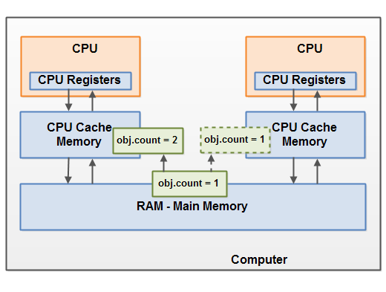

To solve this problem you can use [**Java's volatile keyword**](https://jenkov.com/tutorials/java-concurrency/volatile.html). The volatile keyword can make sure that a given variable is read directly from main memory, and always written back to main memory when updated.

To solve race condition problem you can use a [**Java synchronized block**](https://jenkov.com/tutorials/java-concurrency/synchronized.html). A synchronized block guarantees that only one thread can enter a given critical section of the code at any given time. Synchronized blocks also guarantee that all variables accessed inside the synchronized block will be read in from main memory, and when the thread exits the synchronized block, all updated variables will be flushed back to main memory again, regardless of whether the variable is declared volatile or not.

## The Java synchronized Keyword

Synchronized blocks in Java are marked with the synchronized keyword. A synchronized block in Java is synchronized on some object. All synchronized blocks synchronized on the same object can only have one thread executing inside them at the same time. All other threads attempting to enter the synchronized block are blocked until the thread inside the synchronized block exits the block.

The synchronized keyword can be used to mark four different types of blocks:

1. Instance methods
2. Static methods
3. Code blocks inside instance methods
4. Code blocks inside static methods

Only one thread per instance can execute inside a synchronized instance method. If more than one instance exist, then one thread at a time can execute inside a synchronized instance method per instance. One thread per instance.

Top » Java » Java Concurrency » Java Synchronized Blocks

Java Language

Java Collections

**Java Concurrency**

Java Concurrency Utils

Java Cryptography

Java Date & Time

Java Exception Handling

Java Functional Programming

Java Generics

Java How-To

Java Internationalization

Java IO

Java JavaFX

Java JDBC

Java JSON

Java Logging

Java Multithreaded Servers

Java Networking

Java NIO

Java Performance

Java Persistence

Java Reflection

Java Regular Expressions

Java Servlets

Java Unit Testing

Java XML

Java Zip

Exception Handling Strategies

[Java Concurrency and Multithreading Tutorial](https://jenkov.com/tutorials/java-concurrency/index.html)

[Multithreading Benefits](https://jenkov.com/tutorials/java-concurrency/benefits.html)

[Multithreading Costs](https://jenkov.com/tutorials/java-concurrency/costs.html)

[Concurrency Models](https://jenkov.com/tutorials/java-concurrency/concurrency-models.html)

[Same-threading](https://jenkov.com/tutorials/java-concurrency/same-threading.html)

[Single-threaded Concurrency](https://jenkov.com/tutorials/java-concurrency/single-threaded-concurrency.html)

[Concurrency vs. Parallelism](https://jenkov.com/tutorials/java-concurrency/concurrency-vs-parallelism.html)

[Creating and Starting Java Threads](https://jenkov.com/tutorials/java-concurrency/creating-and-starting-threads.html)

[Java Virtual Threads](https://jenkov.com/tutorials/java-concurrency/java-virtual-threads.html)

[Race Conditions and Critical Sections](https://jenkov.com/tutorials/java-concurrency/race-conditions-and-critical-sections.html)

[Thread Safety and Shared Resources](https://jenkov.com/tutorials/java-concurrency/thread-safety.html)

[Thread Safety and Immutability](https://jenkov.com/tutorials/java-concurrency/thread-safety-and-immutability.html)

[Java Memory Model](https://jenkov.com/tutorials/java-concurrency/java-memory-model.html)

[Java Happens Before Guarantee](https://jenkov.com/tutorials/java-concurrency/java-happens-before-guarantee.html)

[**Java Synchronized Blocks**](https://jenkov.com/tutorials/java-concurrency/synchronized.html)

[Java Volatile Keyword](https://jenkov.com/tutorials/java-concurrency/volatile.html)

[CPU Cache Coherence in Java Concurrency](https://jenkov.com/tutorials/java-concurrency/cache-coherence-in-java-concurrency.html)

[False Sharing in Java](https://jenkov.com/tutorials/java-concurrency/false-sharing.html)

[Java ThreadLocal](https://jenkov.com/tutorials/java-concurrency/threadlocal.html)

[Thread Signaling](https://jenkov.com/tutorials/java-concurrency/thread-signaling.html)

[Deadlock](https://jenkov.com/tutorials/java-concurrency/deadlock.html)

[Deadlock Prevention](https://jenkov.com/tutorials/java-concurrency/deadlock-prevention.html)

[Starvation and Fairness](https://jenkov.com/tutorials/java-concurrency/starvation-and-fairness.html)

[Nested Monitor Lockout](https://jenkov.com/tutorials/java-concurrency/nested-monitor-lockout.html)

[Slipped Conditions](https://jenkov.com/tutorials/java-concurrency/slipped-conditions.html)

[Locks in Java](https://jenkov.com/tutorials/java-concurrency/locks.html)

[Read / Write Locks in Java](https://jenkov.com/tutorials/java-concurrency/read-write-locks.html)

[Reentrance Lockout](https://jenkov.com/tutorials/java-concurrency/reentrance-lockout.html)

[Semaphores](https://jenkov.com/tutorials/java-concurrency/semaphores.html)

[Blocking Queues](https://jenkov.com/tutorials/java-concurrency/blocking-queues.html)

[The Producer Consumer Pattern](https://jenkov.com/tutorials/java-concurrency/producer-consumer.html)

[Thread Pools](https://jenkov.com/tutorials/java-concurrency/thread-pools.html)

[Thread Congestion in Java](https://jenkov.com/tutorials/java-concurrency/thread-congestion.html)

[Compare and Swap](https://jenkov.com/tutorials/java-concurrency/compare-and-swap.html)

[Anatomy of a Synchronizer](https://jenkov.com/tutorials/java-concurrency/anatomy-of-a-synchronizer.html)

[Non-blocking Algorithms](https://jenkov.com/tutorials/java-concurrency/non-blocking-algorithms.html)

[Amdahl's Law](https://jenkov.com/tutorials/java-concurrency/amdahls-law.html)

[Java Concurrency References](https://jenkov.com/tutorials/java-concurrency/references.html)

# Java Synchronized Blocks

* [Java Synchronized Tutorial Video](https://jenkov.com/tutorials/java-concurrency/synchronized.html#java-synchronized-tutorial-video)
* [Java Concurrency Utilities](https://jenkov.com/tutorials/java-concurrency/synchronized.html#java-concurrency-utilities)
* [The Java synchronized Keyword](https://jenkov.com/tutorials/java-concurrency/synchronized.html#synchronized-keyword)
* [Synchronized Instance Methods](https://jenkov.com/tutorials/java-concurrency/synchronized.html#synchronized-instance-methods)
* [Synchronized Static Methods](https://jenkov.com/tutorials/java-concurrency/synchronized.html#synchronized-static-methods)
* [Synchronized Blocks in Instance Methods](https://jenkov.com/tutorials/java-concurrency/synchronized.html#synchronized-blocks-instance-methods)
* [Synchronized Blocks in Static Methods](https://jenkov.com/tutorials/java-concurrency/synchronized.html#synchronized-blocks-static-methods)
* [Synchronized Blocks in Lambda Expressions](https://jenkov.com/tutorials/java-concurrency/synchronized.html#synchronized-blocks-in-lambda-expressions)
* [Java Synchronized Example](https://jenkov.com/tutorials/java-concurrency/synchronized.html#java-synchronized-example)
* [Synchronized and Data Visibility](https://jenkov.com/tutorials/java-concurrency/synchronized.html#synchronized-and-data-visibility)
* [Synchronized and Instruction Reordering](https://jenkov.com/tutorials/java-concurrency/synchronized.html#synchronized-and-instruction-reordering)
* [What Objects to Synchronize On](https://jenkov.com/tutorials/java-concurrency/synchronized.html#what-objects-to-synchronize-on)
* [Synchronized Block Limitations and Alternatives](https://jenkov.com/tutorials/java-concurrency/synchronized.html#synchronized-block-limitations-and-alternatives)
* [Synchronized Block Performance Overhead](https://jenkov.com/tutorials/java-concurrency/synchronized.html#synchronized-block-performance-overhead)
* [Synchronized Block Reentrance](https://jenkov.com/tutorials/java-concurrency/synchronized.html#synchronized-block-reentrance)
* [Synchronized Blocks in Cluster Setups](https://jenkov.com/tutorials/java-concurrency/synchronized.html#synchronized-blocks-in-cluster-setups)

|  |  |
| --- | --- |
| Jakob Jenkov | Jakob Jenkov Last update: 2020-08-12  [Follow on Twitter](https://twitter.com/#!/jjenkov) [Connect on LinkedIn](http://www.linkedin.com/pub/jakob-jenkov/0/a8/4a3) [Subscribe on YouTube](https://www.youtube.com/user/jjenkov) [Subscribe to RSS Feed](http://jenkov.com/rss.xml) [Subscribe to Telegram Channel](https://t.me/jenkov_com) |

A Java synchronized block marks a method or a block of code as synchronized. A synchronized block in Java can only be executed a single thread at a time (depending on how you use it). Java synchronized blocks can thus be used to avoid [**race conditions**](https://jenkov.com/tutorials/java-concurrency/race-conditions-and-critical-sections.html). This Java synchronized tutorial explains how the Java synchronized keyword works in more detail.

## Java Synchronized Tutorial Video

If you prefer video, I have a video version of this Java synchronized tutorial here:  
[**Java Synchronized Tutorial**](https://www.youtube.com/watch?v=eKWjfZ-TUdo&list=PLL8woMHwr36EDxjUoCzboZjedsnhLP1j4&index=6)

**[](https://www.youtube.com/watch?v=eKWjfZ-TUdo&list=PLL8woMHwr36EDxjUoCzboZjedsnhLP1j4&index=6)**

## Java Concurrency Utilities

The synchronized mechanism was Java's first mechanism for synchronizing access to objects shared by multiple threads. The synchronized mechanism isn't very advanced though. That is why Java 5 got a whole set of [**concurrency utility classes**](https://jenkov.com/java-util-concurrent/index.html) to help developers implement more fine grained concurrency control than what you get with synchronized.

## The Java synchronized Keyword

Synchronized blocks in Java are marked with the synchronized keyword. A synchronized block in Java is synchronized on some object. All synchronized blocks synchronized on the same object can only have one thread executing inside them at the same time. All other threads attempting to enter the synchronized block are blocked until the thread inside the synchronized block exits the block.

The synchronized keyword can be used to mark four different types of blocks:

1. Instance methods
2. Static methods
3. Code blocks inside instance methods
4. Code blocks inside static methods

These blocks are synchronized on different objects. Which type of synchronized block you need depends on the concrete situation. Each of these synchronized blocks will be explained in more detail below.

## Synchronized Instance Methods

Here is a synchronized instance method:

public class MyCounter {

private int count = 0;

public **synchronized** void add(int value){

this.count += value;

}

}

Notice the use of the synchronized keyword in the add() method declaration. This tells Java that the method is synchronized.

A synchronized instance method in Java is synchronized on the instance (object) owning the method. Thus, each instance has its synchronized methods synchronized on a different object: the owning instance.

Only one thread per instance can execute inside a synchronized instance method. If more than one instance exist, then one thread at a time can execute inside a synchronized instance method per instance. One thread per instance.

This is true across all synchronized instance methods for the same object (instance). Thus, in the following example, only one thread can execute inside either of of the two synchronized methods. One thread in total per instance:

public class MyCounter {

private int count = 0;

public **synchronized** void add(int value){

this.count += value;

}

public **synchronized** void subtract(int value){

this.count -= value;

}

}

## Synchronized Static Methods

Static methods are marked as synchronized just like instance methods using the synchronized keyword. Here is a Java synchronized static method example:

public static MyStaticCounter{

private static int count = 0;

public **static synchronized** void add(int value){

count += value;

}

}

Also here the synchronized keyword tells Java that the add() method is synchronized.

Synchronized static methods are synchronized on the class object of the class the synchronized static method belongs to. Since only one class object exists in the Java VM per class, only one thread can execute inside a static synchronized method in the same class.

In case a class contains more than one static synchronized method, only one thread can execute inside any of these methods at the same time. Look at this static synchronized method example:

public static MyStaticCounter{

private static int count = 0;

public **static synchronized** void add(int value){

count += value;

}

public **static synchronized** void subtract(int value){

count -= value;

}

}

Only one thread can execute inside any of the two add() and subtract() methods at any given time. If Thread A is executing add() then Thread B cannot execute neither add() nor subtract() until Thread A has exited add().

Java Volatile Keyword:

The Java volatile keyword is used to mark a Java variable as "being stored in main memory". More precisely that means, that every read of a volatile variable will be read from the computer's main memory, and not from the CPU registers, and that every write to a volatile variable will be written to main memory, and not just to the CPU registers.

Important: Why because everytime Thread means CPU will read value from Main Memory(RAM) and puts into CPU Registers so Thread will update the value in CPU Registers and then commits to Main memory.

In a multithreaded application where the threads operate on non-volatile variables, each thread may copy variables from main memory into a CPU registers while working on them, for performance reasons. If your computer contains more than one CPU, each thread may run on a different CPU. That means, that each thread may copy the variables into the CPU registers of different CPUs. This is illustrated here:

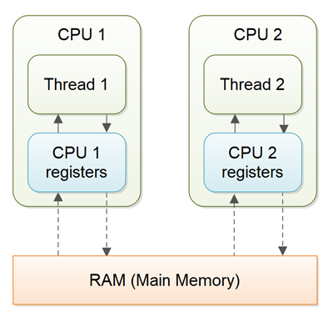

With non-volatile variables there are no guarantees about when the Java Virtual Machine (JVM) reads data from main memory into CPU registers, or writes data from CPU registers to main memory. This can cause several problems which I will explain in the following sections.

The Java volatile keyword is intended to address variable visibility problems. By declaring the counter variable volatile all writes to the counter variable will be written back to main memory immediately. Also, all reads of the counter variable will be read directly from main memory.

## Thread Deadlock

A deadlock is when two or more threads are blocked waiting to obtain locks that some of the other threads in the deadlock are holding. Deadlock can occur when multiple threads need the same locks, at the same time, but obtain them in different order.

If thread 1 locks A, and tries to lock B, and thread 2 has already locked B, and tries to lock A, a deadlock arises. Thread 1 can never get B, and thread 2 can never get A. In addition, neither of them will ever know. They will remain blocked on each their object, A and B, forever. This situation is a deadlock.

## Deadlock Prevention

## Lock Ordering

Deadlock occurs when multiple threads need the same locks but obtain them in different order.

If you make sure that all locks are always taken in the same order by any thread, deadlocks cannot occur. Look at this example:

Thread 1:

lock A

lock B

Thread 2:

wait for A

lock C (when A locked)

Thread 3:

wait for A

wait for B

wait for C

If a thread, like Thread 3, needs several locks, it must take them in the decided order. It cannot take a lock later in the sequence until it has obtained the earlier locks.

For instance, neither Thread 2 or Thread 3 can lock C until they have locked A first. Since Thread 1 holds lock A, Thread 2 and 3 must first wait until lock A is unlocked. Then they must succeed in locking A, before they can attempt to lock B or C.

1. **public** **class** TestDeadlockExample1 {
2. **public** **static** **void** main(String[] args) {
3. **final** String resource1 = "ratan jaiswal";
4. **final** String resource2 = "vimal jaiswal";
5. // t1 tries to lock resource1 then resource2
6. Thread t1 = **new** Thread() {
7. **public** **void** run() {
8. **synchronized** (resource1) {
9. System.out.println("Thread 1: locked resource 1");
11. **try** { Thread.sleep(100);} **catch** (Exception e) {}
13. **synchronized** (resource2) {
14. System.out.println("Thread 1: locked resource 2");
15. }
16. }
17. }
18. };
20. // t2 tries to lock resource2 then resource1
21. Thread t2 = **new** Thread() {
22. **public** **void** run() {
23. **synchronized** (resource2) {
24. System.out.println("Thread 2: locked resource 2");
26. **try** { Thread.sleep(100);} **catch** (Exception e) {}
28. **synchronized** (resource1) {
29. System.out.println("Thread 2: locked resource 1");
30. }
31. }
32. }
33. };

36. t1.start();
37. t2.start();
38. }
39. }
40. **Output:**
41. Thread 1: locked resource 1
42. Thread 2: locked resource 2

So to avoid deadlock, always decide the order of locks

2012-12-27 19:08:34

Full thread dump Java HotSpot(TM) 64-Bit Server VM (23.5-b02 mixed mode):

"Attach Listener" daemon prio=5 tid=0x00007fb0a2814000 nid=0x4007 waiting on condition [0x0000000000000000]

java.lang.Thread.State: RUNNABLE

"DestroyJavaVM" prio=5 tid=0x00007fb0a2801000 nid=0x1703 waiting on condition [0x0000000000000000]

java.lang.Thread.State: RUNNABLE

"t3" prio=5 tid=0x00007fb0a204b000 nid=0x4d07 waiting for monitor entry [0x000000015d971000]

java.lang.Thread.State: BLOCKED (on object monitor)

at com.journaldev.threads.SyncThread.run(ThreadDeadlock.java:41)

- waiting to lock <0x000000013df2f658> (a java.lang.Object)

- locked <0x000000013df2f678> (a java.lang.Object)

at java.lang.Thread.run(Thread.java:722)

"t2" prio=5 tid=0x00007fb0a1073000 nid=0x4207 waiting for monitor entry [0x000000015d209000]

java.lang.Thread.State: BLOCKED (on object monitor)

at com.journaldev.threads.SyncThread.run(ThreadDeadlock.java:41)

- waiting to lock <0x000000013df2f678> (a java.lang.Object)

- locked <0x000000013df2f668> (a java.lang.Object)

at java.lang.Thread.run(Thread.java:722)

"t1" prio=5 tid=0x00007fb0a1072000 nid=0x5503 waiting for monitor entry [0x000000015d86e000]

java.lang.Thread.State: BLOCKED (on object monitor)

at com.journaldev.threads.SyncThread.run(ThreadDeadlock.java:41)

- waiting to lock <0x000000013df2f668> (a java.lang.Object)

- locked <0x000000013df2f658> (a java.lang.Object)

at java.lang.Thread.run(Thread.java:722)

"Service Thread" daemon prio=5 tid=0x00007fb0a1038000 nid=0x5303 runnable [0x0000000000000000]

java.lang.Thread.State: RUNNABLE

"C2 CompilerThread1" daemon prio=5 tid=0x00007fb0a1037000 nid=0x5203 waiting on condition [0x0000000000000000]

java.lang.Thread.State: RUNNABLE

"C2 CompilerThread0" daemon prio=5 tid=0x00007fb0a1016000 nid=0x5103 waiting on condition [0x0000000000000000]

java.lang.Thread.State: RUNNABLE

"Signal Dispatcher" daemon prio=5 tid=0x00007fb0a4003000 nid=0x5003 runnable [0x0000000000000000]

java.lang.Thread.State: RUNNABLE

"Finalizer" daemon prio=5 tid=0x00007fb0a4800000 nid=0x3f03 in Object.wait() [0x000000015d0c0000]

java.lang.Thread.State: WAITING (on object monitor)

at java.lang.Object.wait(Native Method)

- waiting on <0x000000013de75798> (a java.lang.ref.ReferenceQueue$Lock)

at java.lang.ref.ReferenceQueue.remove(ReferenceQueue.java:135)

- locked <0x000000013de75798> (a java.lang.ref.ReferenceQueue$Lock)

at java.lang.ref.ReferenceQueue.remove(ReferenceQueue.java:151)

at java.lang.ref.Finalizer$FinalizerThread.run(Finalizer.java:177)

"Reference Handler" daemon prio=5 tid=0x00007fb0a4002000 nid=0x3e03 in Object.wait() [0x000000015cfbd000]

java.lang.Thread.State: WAITING (on object monitor)

at java.lang.Object.wait(Native Method)

- waiting on <0x000000013de75320> (a java.lang.ref.Reference$Lock)

at java.lang.Object.wait(Object.java:503)

at java.lang.ref.Reference$ReferenceHandler.run(Reference.java:133)

- locked <0x000000013de75320> (a java.lang.ref.Reference$Lock)

"VM Thread" prio=5 tid=0x00007fb0a2049800 nid=0x3d03 runnable

"GC task thread#0 (ParallelGC)" prio=5 tid=0x00007fb0a300d800 nid=0x3503 runnable

"GC task thread#1 (ParallelGC)" prio=5 tid=0x00007fb0a2001800 nid=0x3603 runnable

"GC task thread#2 (ParallelGC)" prio=5 tid=0x00007fb0a2003800 nid=0x3703 runnable

"GC task thread#3 (ParallelGC)" prio=5 tid=0x00007fb0a2004000 nid=0x3803 runnable

"GC task thread#4 (ParallelGC)" prio=5 tid=0x00007fb0a2005000 nid=0x3903 runnable

"GC task thread#5 (ParallelGC)" prio=5 tid=0x00007fb0a2005800 nid=0x3a03 runnable

"GC task thread#6 (ParallelGC)" prio=5 tid=0x00007fb0a2006000 nid=0x3b03 runnable

"GC task thread#7 (ParallelGC)" prio=5 tid=0x00007fb0a2006800 nid=0x3c03 runnable

"VM Periodic Task Thread" prio=5 tid=0x00007fb0a1015000 nid=0x5403 waiting on condition

JNI global references: 114

Found one Java-level deadlock:

=============================

"t3":

waiting to lock monitor 0x00007fb0a1074b08 (object 0x000000013df2f658, a java.lang.Object),

which is held by "t1"

"t1":

waiting to lock monitor 0x00007fb0a1010f08 (object 0x000000013df2f668, a java.lang.Object),

which is held by "t2"

"t2":

waiting to lock monitor 0x00007fb0a1012360 (object 0x000000013df2f678, a java.lang.Object),

which is held by "t3"

Java stack information for the threads listed above:

===================================================

"t3":

at com.journaldev.threads.SyncThread.run(ThreadDeadlock.java:41)

- waiting to lock <0x000000013df2f658> (a java.lang.Object)

- locked <0x000000013df2f678> (a java.lang.Object)

at java.lang.Thread.run(Thread.java:722)

"t1":

at com.journaldev.threads.SyncThread.run(ThreadDeadlock.java:41)

- waiting to lock <0x000000013df2f668> (a java.lang.Object)

- locked <0x000000013df2f658> (a java.lang.Object)

at java.lang.Thread.run(Thread.java:722)

"t2":

at com.journaldev.threads.SyncThread.run(ThreadDeadlock.java:41)

- waiting to lock <0x000000013df2f678> (a java.lang.Object)

- locked <0x000000013df2f668> (a java.lang.Object)

at java.lang.Thread.run(Thread.java:722)

Found 1 deadlock.